PORTFOLIO ASSESSMENT GUIDE for

BUS 220: Business Communications

What is a Portfolio:
A Portfolio is a formal means of requesting assessment of your prior work/life experience from which you have developed sufficient college-level learning to earn credit for a specific class.

Purpose of this Guide:
This document is intended for student self-assessment purposes only. Review it carefully to determine if you are ready to write and submit a Portfolio for the course indicated above. Your self-assessment is not a guarantee that you will be awarded credit for the course. Faculty with expertise in the subject matter will evaluate whether your Portfolio provides sufficient evidence that you have demonstrated appropriate college-level mastery of the course content through experiential learning.

General Guidelines:
- All work must be word-processed, except for documentation provided.
- Written portions should demonstrate college-level writing skills, including appropriate citations for any quoted or paraphrased material from other sources.
- Use the provided template, located on page 3 of the guide, to format the portfolio appropriately.
- Your Portfolio will not be returned. Make copies of the contents before you submit. You may include clear copies of documentation and keep the originals.
- Submit your completed Portfolio, along with the approved Course Portfolio Assessment Form, to the Adult Learning Coordinator.

Determination of Portfolio Assessment Outcome:
You will need to do the following to be awarded credit through Portfolio Assessment for this course:

- Provide all required documentation as listed within the template to support the Learning Outcomes.
- Possibly participate in an interview with the Portfolio evaluator.
- When evaluated, students must earn a 3 or higher on at least four of the five learning outcomes (based on the rubric provided below).

1  Does not Meet  Expectations | Evidence demonstrates very low level of mastery of this outcome. The evidence is unconvincing, incomplete, very inadequate, contains many inaccuracies, and/or is marked by major conceptual problems.
2  Needs Improvement | Evidence demonstrates inadequate mastery of this outcome. Although some aspects of the work may be acceptable, too much of the evidence is unconvincing, incomplete, inadequate, contains multiple inaccuracies,  and/or demonstrates major conceptual problems.
3  Adequately Meets  Expectations | Evidence demonstrates adequate mastery of this outcome. Although it is not perfect, the work is fairly complete, accurate, and free of major conceptual problems.
4  Exceeds Expectations | Evidence demonstrates sophisticated mastery of this outcome. Work is complete, accurate, and free of conceptual problems.

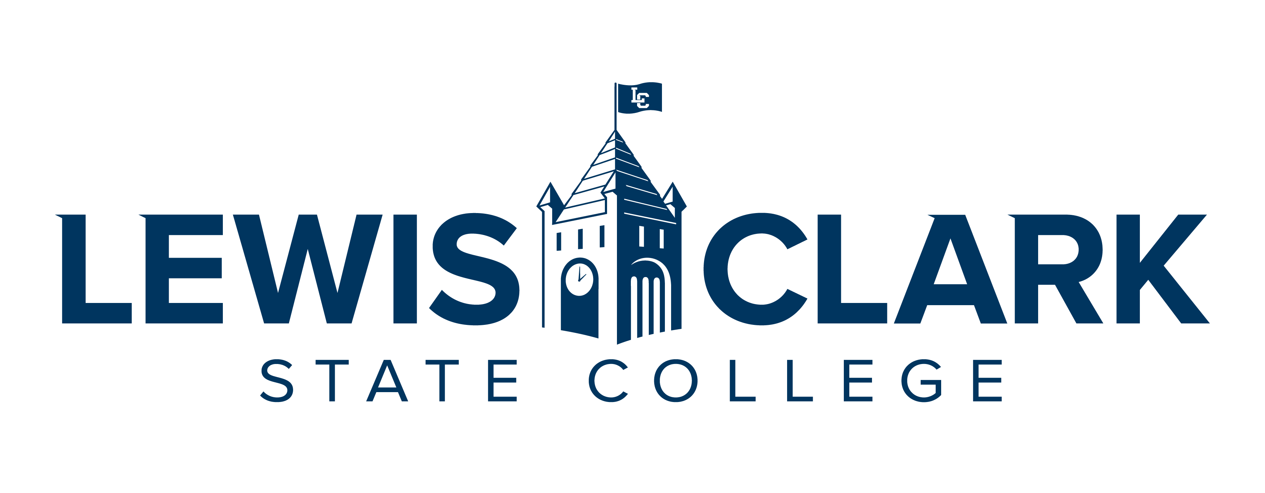

CREDIT FOR PRIOR LEARNING PORTFOLIO
FOR
BUSINESS 220: BUSINESS COMMUNICATIONS

(DATE)

BY

(YOUR NAME)

Table of Contents
Contents
Statement of Academic Honesty 3
Course Description 3
Learning Outcomes 4
Educational Goals 4
Chronological Resume 5
Learning and Experience Autobiography 6
Acquired Learning and Knowledge Narrative 7
Bibliography 8
Documentation 8

Statement of Academic Honesty

The material contained in this Portfolio honestly and accurately reflects my life, learning, and work experience. I understand that the penalty for falsifying any information or documentation will result in an award of no credit for the Portfolio with no resubmission allowed and may result in other sanctions as described in the Student Code of Conduct.

Print Name LCSC ID Number

_____________________________ ____________________
Signature Date

Course Description
BUS 220 BUSINESS COMMUNICATIONS
Provides students with written and verbal skills to communicate effectively in the business environment. Written skills range from basic grammar and punctuation techniques to writing business memos and reports. Verbal skill situations include preparing presentations and interviews and directing meetings.

Learning Outcomes

- Understand the importance of effective communication in the workplace;
- Explain what it means to communicate as a professional in a business context;
- Define ethics, explain an ethical dilemma, and understand guidelines for making ethical choices;
- List key steps needed to ensure productive team meetings;
- Identify modes of listening, describe the listening process, and explain selective listening;
- Explain the importance of business etiquette and identify key areas in which good etiquette is essential;
- Describe the 3-step writing process & apply/adapt via various applications;
- Explain how establishing credibility is vital to building strong relationships with audiences;
- Describe steps to improve writing clarity and tips for making writing more concise;
- Describe an effective process for business research and define secondary and primary research;
- Identify steps for delivering a successful presentation;
- Build Career tools such as resume, cover letter and interview preparations

Educational Goals
Goals, Motivation, and Time Frame
What are your goals? What are the reasons (professional and personal) you are pursuing your goals? What is a realistic time frame for completing your education?
Prior Learning to Goals
How will the prior learning credit you are requesting fit into their future educational and career goals?

Chronological Resume

Include a chronological resume that will support your request for prior learning. List all jobs held, including volunteer, as they relate to the course that you are trying to receive credit. List duties, skills and expertise used in performing job tasks. When possible, use language similar to that used in the outcomes for the courses.
Examples of Experience:
- Employment, Work Experience
- Workshops, Webinars, Training, Seminars, Professional Development
- Volunteer Activities, Community Service, Committees, Groups
- Military Experience, Occupations, Training
- Licenses, Certificates, Industry Credentials
- Non-credit Courses
- Publications

Learning and Experience Autobiography

The autobiography will serve as an introduction to the evaluator and help them understand the context of your learning for the particular course you are requesting. It is a complete picture of you and your experiences as it relates to the course for which you are creating this portfolio. Relate the relevant experiences to the course in a general explanation (Specifics will be included in the Acquired Learning and Knowledge Narrative). Demonstrate why you have selected this particular course and detail your work and life experiences using your resume as a guide.

This should be two+ pages and summarize the significant learning experiences in your life and describe how your experiences will validate your knowledge of the course content and meet the course outcomes being petitioned for credit.

Acquired Learning and Knowledge Narrative

The narrative is a detailed explanation of how your activities and the resulting competencies were achieved. This is to complement your resume and autobiography. Be sure to link your accomplishments to the course learning outcomes. This will be similar to your autobiography, but will detail your chronological work and life experience history while focusing on the things you have already learned through training and experiences, as it relates to your target course.

Note that a key goal of this section is the learning process itself as you reflect on how your experience relates to key concepts within the learning outcomes in the target course. Clearly focus on the learning objectives (what you know and can do) rather than the experience.
For each experience indicated within the Portfolio, the student must:
- Label each heading, Learning Outcome 1, Learning Outcome 2, etc.
- Include the experience; time spent in activity; description of duties and activities.
- Describe the learning and how it relates to the Learning Outcomes for the course.
- Describe how the learning was acquired.
- Provide documentation as evidence of the experience in relation to the course learning outcomes, and as an indication of the level and appropriateness of content.
- Describe how this experience has influenced and impacted other areas of your life.
This will be 2+ pages in length. Make sure it is clear, concise, and free of errors in sentence structure, grammar, and spelling. It needs to demonstrate college-level writing and critical thinking.

Bibliography

This is not required. The bibliography will include any reading done on the course subject. If you have studied manuals or used other texts to gain your prior learning, include them here. References should be cited in American Psychological Association (APA) style, but your instructor may suggest another format.

Documentation
Each of your experiences and competencies will require verification (evidence). This evidence can take several forms:
- Completion of training programs, workshops, seminars, etc., may be verified through:
  - Certificates
  - Personnel records
- Performance reviews showing competencies
- Job descriptions
- Transcripts
- Samples of work
- A videotape of your speech, theatre work, or music recital
- Licenses
- Honors or award
- Samples of your painting, drawing, photography, or ceramics for a studio art course
- Certificates of attendance
- Letters of verification listing proven competencies from instructors or employers
- Products designed or created by you
- Military records
Each piece of documentation for a workshop or training program must be accompanied by a description page of content for each workshop, training program, or seminar and must show how the evidence relates to the course learning outcomes.

