PORTFOLIO ASSESSMENT GUIDE for

ECDPT-112: Infant Toddler Development

What is a Portfolio:
A Portfolio is a formal means of requesting assessment of your prior work/life experience from which you have developed sufficient college-level learning to earn credit for a specific class.

Purpose of this Guide:
This document is intended for student self-assessment purposes only. Review it carefully to determine if you are ready to write and submit a Portfolio for the course indicated above. Your self-assessment is not a guarantee that you will be awarded credit for the course. Faculty with expertise in the subject matter will evaluate whether your Portfolio provides sufficient evidence that you have demonstrated appropriate college-level mastery of the course content through experiential learning.

General Guidelines:
- All work must be word-processed, except for documentation provided.
- Written portions should demonstrate college-level writing skills, including appropriate citations for any quoted or paraphrased material from other sources.
- Use the provided template, located on page 4 of the guide, to format the portfolio appropriately.
- Your Portfolio will not be returned. Make copies of the contents before you submit. You may include clear copies of documentation and keep the originals.
- Submit your completed Portfolio, along with the approved Course Portfolio Assessment Form, to the Adult Learning Coordinator.

Determination of Portfolio Assessment Outcome:
You will need to do the following to be awarded credit through Portfolio Assessment for this course:
- Provide all required documentation as listed within the template to support the Learning Outcomes.
- Possibly participate in an interview with the Portfolio evaluator.
- When evaluated, students must demonstrate experience or proficiency in >=70% to earn credit in the course.

SCORING:

- Exceeds Expectations (4): Documentation provided demonstrates exceptional knowledge and mastery of learning outcomes. Work is thorough and complete, and free of errors in conceptualization.
- Meets Expectations (3): Documentation provided demonstrates adequate knowledge and mastery of learning outcomes. Work is mostly thorough and complete, and has minimal errors in conceptualization.
- Needs Improvement (2): Documentation provided demonstrates inadequate knowledge and mastery of learning outcomes. Work is incomplete with weak evidence and errors are present in conceptualization.
- Does not Meet Expectations (1): Work provides very little evidence of knowledge or mastery of learning outcomes. Significant errors or inaccuracies are evident, as well as, major errors in conceptualization.

Skill/Outcome | Score
Demonstrates an understanding of contemporary theories (attachment theory, psychosocial theory, social learning theory, cognitive theory, and ecological theory) of child development and trends in development and education (family grouping, continuity of care, primary caregiving, and partnerships with families).

Demonstrates understanding of typical patterns of physical and cognitive/language development between birth and 36 months of age, the role adults play in the process of language development, and theories that guide our understanding of cognitive development and scaffolding children’s learning.
- Able to explain the progression of brain development during the first two years of life.
- Demonstrates an awareness of and causes for Shaken Baby Syndrome and potential outcomes for children.
Demonstrates understanding of typical patterns of social and emotional development between birth and 36 months of age, the impact of parent-child interactions on healthy identity development, and impact of secure relationships between adults and infants and toddlers.

Demonstrates an understanding of attachment, the impact of positive early relationships on later development, and awareness of appropriate appreciation strategies and impact on children’s development.

Demonstrates an understanding of how to build relationships and guide behavior in infant and toddler care settings such as appropriate interactions, management of the environment, selection of teaching strategies specific to infants and toddlers, strategies for communicating with young children (i.e., emotional talk), and strategies to support infant toddler emotional regulation.

Demonstrates an understanding of how to create high-quality and developmentally appropriate indoor and outdoor learning environments for infants and toddlers including organization of the classroom environment and appropriate equipment and materials to provide a safe and stimulating learning environment.

Demonstrates an understanding of how to design curriculum for infants and toddlers and considerations for inclusive environments.
- Demonstrates an understanding of the 11 steps of the diapering process.
- Demonstrates an understanding of the importance of flexible schedules for infants and toddlers.
- Demonstrates an understanding of how personal care routines can be used to promote child development and learning.
- Demonstrates an understanding of the significance of daily plans for infants and young children.
- Demonstrates understanding for the appropriateness in creating projects based on children’s interests and abilities rather than theme-based learning.
- Able to describe appropriate materials and experiences, with caregiver strategies for supporting development of physical, cognitive, emotional, and social skills for children birth through twelve months of age.
- Describe materials and experiences, with caregiver strategies for supporting development of physical, cognitive, emotional, and social skills for children twelve to twenty-four months of age.
- Describe materials and experiences, with caregiver strategies for supporting development of physical, cognitive, emotional, and social skills for children twenty-four to thirty-six months of age.

Demonstrate an understanding of the evaluation and assessment process, benefits of early intervention, and how to care for young children with disabilities

Total Points
Total Credits

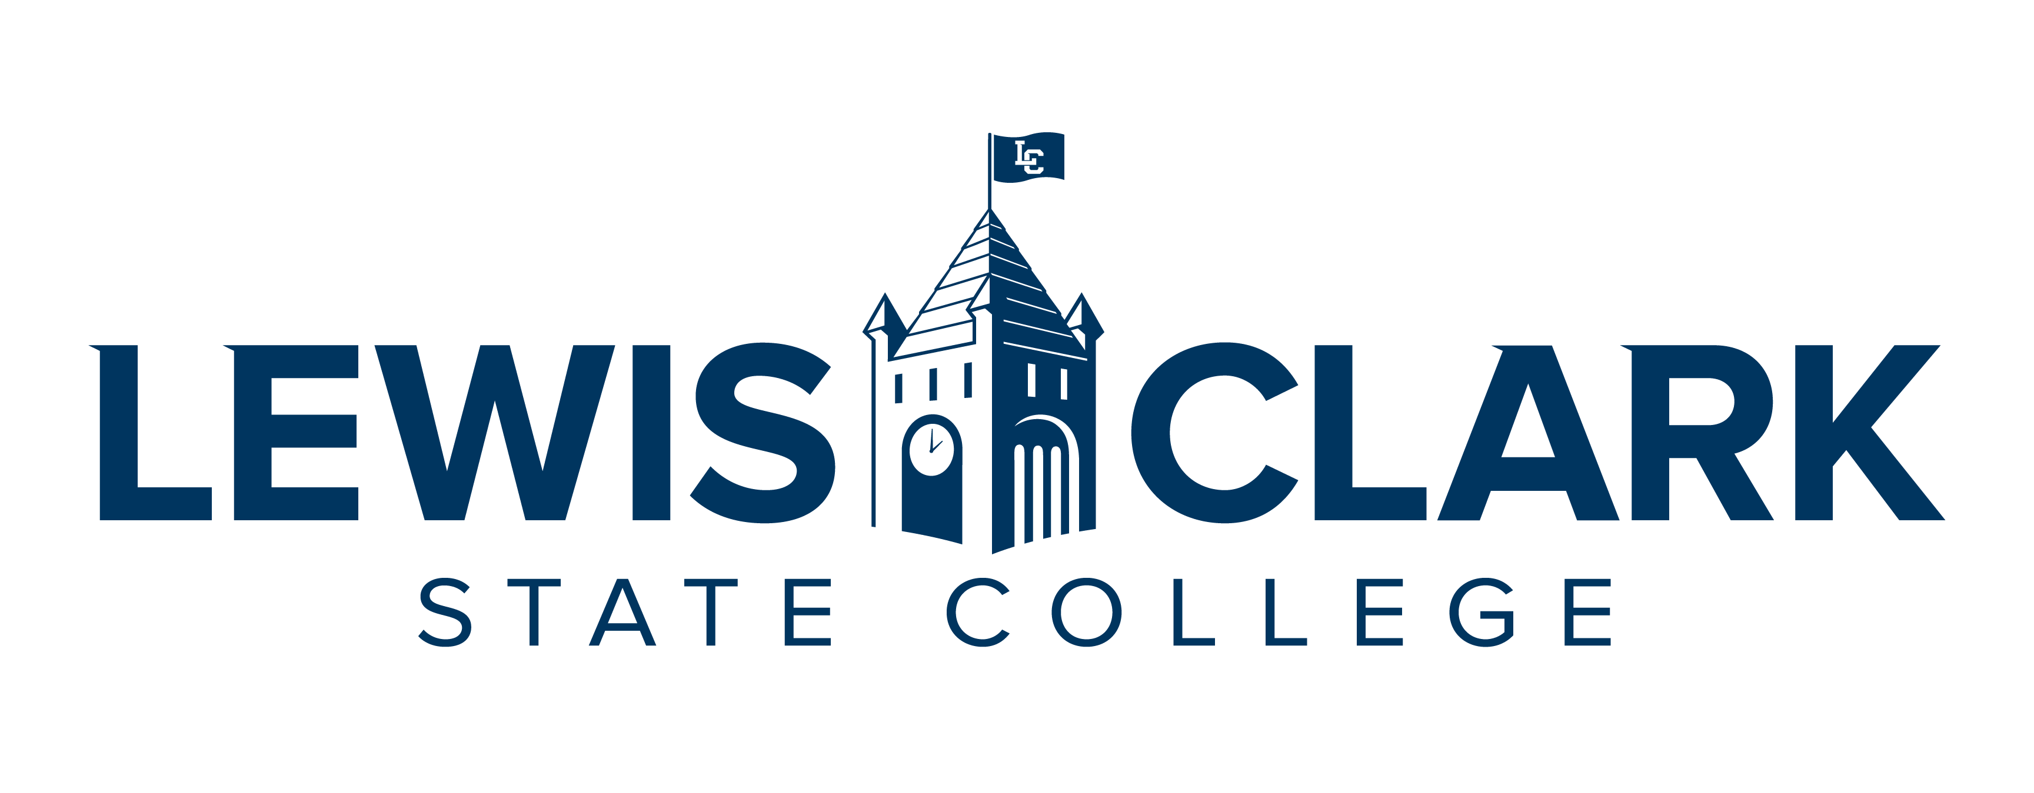

CREDIT FOR PRIOR LEARNING PORTFOLIO
ECDPT-112: Infant Toddler Development
(DATE)

BY

(YOUR NAME)

Table of Contents
Contents
Statement of Academic Honesty 3
Course Description 4
Learning Outcomes 4
Educational Goals 4
Chronological Resume 5
Learning and Experience Autobiography 6
Acquired Learning and Knowledge Narrative 6
Bibliography 7
Documentation 7

Statement of Academic Honesty

The material contained in this Portfolio honestly and accurately reflects my life, learning, and work experience. I understand that the penalty for falsifying any information or documentation will result in an award of no credit for the Portfolio with no resubmission allowed and may result in other sanctions as described in the Student Code of Conduct.

Print Name LCSC ID Number

_____________________________ ____________________
Signature Date

Course Description
ECDPT-112: Infant Toddler Development
Examine the unique developmental needs of infants and toddlers. Study the role of the caregiver, relationships with families, developmentally appropriate practices, nurturing environments for infants and toddlers, and culturally relevant care.
Learning Outcomes
- Describe different contemporary theories of child development and trends in development and early care and education.
- Describe developmental milestones from birth to 36 months articulating the influences of individual development, temperament and cultural norms
- Develop a plan to create reciprocal, culturally sensitive partnerships with families
- Describe state infant/toddler child care regulations and procedures related to group size, health, nutrition, and safety
- Describe guidance techniques that are appropriate and effective with infants and toddlers
- Create and critique infant and toddler early learning environments that support children’s physical, cognitive/language, emotional, creative and social development.
- Construct a plan for developmentally appropriate, culturally relevant curriculum that supports language, physical, cognitive, creative, social, and emotional development
- Identify resources supporting infant/toddler programs and infant/toddler specialists

Educational Goals

Goals, Motivation, and Time Frame
What are your goals? What are the reasons (professional and personal) you are pursuing your goals? What is a realistic time frame for completing your education?
Prior Learning to Goals
How will the prior learning credit you are requesting fit into their future educational and career goals?

Chronological Resume

Include a chronological resume that will support your request for prior learning. List all jobs held, including volunteer, as they relate to the course that you are trying to receive credit. List duties, skills and expertise used in performing job tasks. When possible, use language similar to that used in the outcomes for the courses.
Examples of Experience:
- Employment, Work Experience
- Workshops, Webinars, Training, Seminars, Professional Development
- Volunteer Activities, Community Service, Committees, Groups
- Military Experience, Occupations, Training
- Licenses, Certificates, Industry Credentials
- Non-credit Courses
- Publications

Learning and Experience Autobiography

The autobiography will serve as an introduction to the evaluator and help them understand the context of your learning for the particular course you are requesting. It is a complete picture of you and your experiences as it relates to the course for which you are creating this portfolio. Relate the relevant experiences to the course in a general explanation (Specifics will be included in the Acquired Learning and Knowledge Narrative). Demonstrate why you have selected this particular course and detail your work and life experiences using your resume as a guide.

This should be two+ pages and summarize the significant learning experiences in your life and describe how your experiences will validate your knowledge of the course content and meet the course outcomes being petitioned for credit.

Acquired Learning and Knowledge Narrative

The narrative is a detailed explanation of how your activities and the resulting competencies were achieved. This is to complement your resume and autobiography. Be sure to link your accomplishments to the course learning outcomes. This will be similar to your autobiography, but will detail your chronological work and life experience history while focusing on the things you have already learned through training and experiences, as it relates to your target course.

Note that a key goal of this section is the learning process itself as you reflect on how your experience relates to key concepts within the learning outcomes in the target course. Clearly focus on the learning objectives (what you know and can do) rather than the experience.
For each experience indicated within the Portfolio, the student must:
- Label each heading, Learning Outcome 1, Learning Outcome 2, etc.
- Include the experience; time spent in activity; description of duties and activities.
- Describe the learning and how it relates to the Learning Outcomes for the course.
- Describe how the learning was acquired.
- Provide documentation as evidence of the experience in relation to the course learning outcomes, and as an indication of the level and appropriateness of content.
- Describe how this experience has influenced and impacted other areas of your life.
This will be 2+ pages in length. Make sure it is clear, concise, and free of errors in sentence structure, grammar, and spelling. It needs to demonstrate college-level writing and critical thinking.

Bibliography

This is not required. The bibliography will include any reading done on the course subject. If you have studied manuals or used other texts to gain your prior learning, include them here. References should be cited in American Psychological Association (APA) style, but your instructor may suggest another format.

Documentation

Each of your experiences and competencies will require verification (evidence). This evidence can take several forms:
- Completion of training programs, workshops, seminars, etc., may be verified through:
  - Certificates
  - Personnel records
- Performance reviews showing competencies
- Job descriptions
- Transcripts
- Samples of work
- A videotape of your speech, theatre work, or music recital
- Licenses
- Honors or award
- Samples of your painting, drawing, photography, or ceramics for a studio art course
- Certificates of attendance
- Letters of verification listing proven competencies from instructors or employers
- Products designed or created by you
- Military records
Each piece of documentation for a workshop or training program must be accompanied by a description page of content for each workshop, training program, or seminar and must show how the evidence relates to the course learning outcomes.

