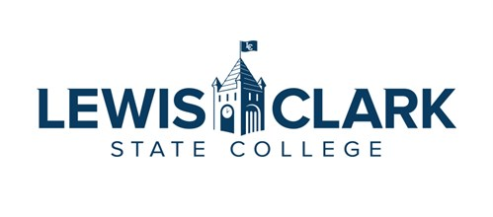
Welcome to Lewis-Clark State College!
Sample Itinerary – Professional Staff
Date
(All Interview Times are PST)
Interview Time | Meeting | Zoom Link/Location
8:15 – 9:00 a.m. | Meet with Search Committee
9:00 – 9:30 a.m. | Meet with Vice President
9:30 – 10:00 a.m. | Meet with Office Staff
10:00 – 10:30 a.m. | Meet with Directors of Department
10:30 – 10:45 a.m. | Break
10:45 – 11:00 a.m. | LC State Benefits Overview with Amanda Greco, HR Associate
11:00 – 11:45 a.m. | Campus Forum Optional
11:45 – 12:30 p.m. | Tour of Campus
2:00 p.m. | President Pemberton – Director/VP Level Only

