HRS 2023 Quarterly Newsletter!
Idaho Human Right’s Day | January 16, 2023
President’s Day | February 20, 2023
Upcoming Holidays January, February, and March:
PLEASE CONTACT PAYROLL FOR INFORMATION ON I-TIME CODING
PERFORMANCE EVALUATION SEASON
As you all know, it is Performance Evaluation season!
Performance Evaluations for Professional and Classified Staff must be completed by January 31, 2023.

New Year Challenges!
Declutter Your Life Challenge – Now this one is a whole year challenge! We all have too much “stuff” that we aren’t sure what to do with. If you are feeling the weight of having too many things and not enough space, this is a great challenge for you. Every week, on Friday, I will send you a new “small” challenge for the weekend to help you start to declutter your homes, your life and your workplace. The goal is to do a little each week. They won’t take much time but by January 2024, you will have a ton less clutter than you started with. This doesn’t require you to come to a class; it is just a quick email that you will get each week with your “mini challenge” for the next 7 days. Sign up If you are interested in decluttering your life at https://uidaho.co1.qualtrics.com/jfe/form/SV_exlzvyzhnhZldEa.

Broke January” Challenge – Every year, I advise folks to do something crazy… and hard… but oh, so helpful. It is called “Broke January.” We focus on the necessities of our budget… rent/mortgage, utilities, transportation, food, insurance, childcare (and credit card bills). What we don’t do is add any more debt or unnecessary expenses to our budget! Ok… are ya ready? No eating out, no shopping, no coffee at Starbucks or Dutch Bros (sorry guys at the coffee shops), no movies, no entertainment (unless it is free), no new debt, no manicures, no lottery tickets, no using your credit cards… AT ALL!!! :0. You can ONLY purchase the stuff that you need to keep a warm roof over your head, food in your tummy and your body at work.
BUT you aren’t alone in this. Sign up for this challenge and each week, we will meet to support each other and to get/give helpful tips on how we did for the week. Yes, you heard right… “we” – I am doing this right along with you! Our meetings will be every Friday at 10:00 am (Pacific Time) on Zoom. If you can’t meet then but want to join the group, email me and we will get you the recordings and some useful resources to help you through the month. The great thing about this “reset” is that you will find in February that it really wasn’t as hard as you thought; you have a ton of cash left over because you weren’t spending it on all the “little” things; and you feel a lot less “broke.”
So, who’s in? The challenge starts on January 1… the first week is “on you” … no spending other than essentials. Sign up here for our first meeting, January 6th at 10:00 am, (every Friday for 4 weeks) to share how you are doing. https://uidaho.zoom.us/meeting/register/tZwtce6przMtHNTnjboh8HkcaE97eIjgRhPA
To sweeten the pot, for one lucky winner who completes this challenge (comes to all 4 meetings), there will be an Amazon gift card waiting at the end.

January Micro-Learning Modules

DHR’s micro-learning modules are back!
*Additional spaces have been added to each session
These one-hour webinars are a great introduction for those who have not attended our full day courses and serve as an excellent refresher for staff who have completed DHR trainings before. All micro-learning modules are available for free to all State of Idaho employees!
*Please note: PHD employees will be invoiced an additional $20.00 per module.

January Spotlight

Documenting Performance is designed to provide participants the skill to document effectively. Participants will learn a simple process to follow and understand its importance in

supporting evaluations and preventing legal claims. Case review and sample activities will give participants a hands-on learning experience to effective documentation.
January 18, 2023 2:00 pm - 3:00 pm MST
Register Here

Performance Evaluations  January 23, 2023  10:00 am - 11:00 am MST  Register Here | Progressive Discipline  January 11, 2023  10:00 am - 11:00 am MST  Register Here

Coaching  January 30, 2023  10:00 am - 11:00 am MST  Register Here | Motivation  January 25, 2023  2:00 pm - 3:00 pm MST  Register Here

Communication  January 18, 2023  10:30 am - 11:30 am MST  Register Here | Accountability  January 25, 2023  10:30 am - 11:30 am MST  Register Here

Setting Expectations  January 9, 2023  10:00 am - 11:00 am MST  Register Here | Providing Feedback  January 24, 2023  2:00 pm - 3:00 pm MST  Register Here

Emotional Intelligence  January 11, 2023  2:00 pm - 3:00 pm MST  Register Here | Leaders In Motion  January 30, 2023  1:00 pm - 2:00 pm MST  Register Here

Learn a Latte’ with HR!

Join us in learning about a different LC State function/department every other Friday! This year, these will be held in person!

Have a Learn a Latte’ presenter request? Send them to akgreco@lcsc.edu!
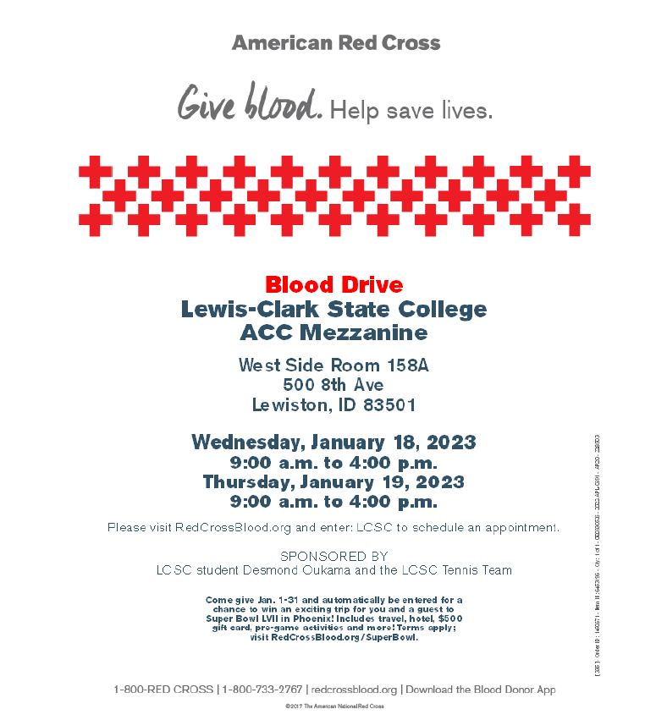
Butternut Squash Flatbread

Ingredients
- 1 tablespoon cornmeal, or as needed
- 1-pound prepared whole-wheat pizza dough
- 1 tablespoon olive oil
- 4 ounces low-fat mozzarella cheese, grated
- 2 cups cooked butternut squash cubes
- ½ cup thinly-sliced red onion
- 1 tablespoon grated Parmesan cheese, or to taste
- ground black pepper
- 3 cloves garlic, minced

Directions
- Preheat oven to 450 degrees F (230 degrees C). Sprinkle cornmeal onto a baking sheet.
- Roll out dough to 1/4-inch thickness using a rolling pin on a work surface. Place dough on prepared baking sheet and brush olive oil thoroughly over surface. Layer dough with mozzarella cheese, butternut squash, and red onion. Sprinkle dough with Parmesan cheese and black pepper; top with garlic.
- Bake in the preheated oven until golden brown, 25 to 30 minutes.

Name | Position | Department
Jim Arellanes | Custodian | Physical Plant
Danita Burch | Security Officer, Senior | Public Safety
Haylie Betham | Scholarship Coordinator | Financial Aid
Jennifer Hankins | Librarian | Library

Date | Name
1 | Clay Robinson
2 | Joelle Candler
2 | Robert Sobotta
3 | Benjamin Gonzales
4 | Kevin Grote
6 | Brandon Ohmie
7 | Tim Cole
10 | Vicki Cooper
10 | George Laughlin
11 | Rhonda Zenner
14 | LeeAnn Wiggin
14 | Rachel Kaitz
16 | Ashley James
18 | Michelle Pearson-Smith
20 | Deena Rauch
20 | Dovie Willey
20 | Muna Crook
21 | Glory Deniston
21 | Alex Briggs
21 | Ashley Boyle
22 | Elisabeth Murillo
23 | Justin Louchart
23 | John Morrison
23 | Kerensa Allison
25 | Jessica Schumacher
26 | Christina Sorenson
26 | Caelyn Orlandi
27 | Amanda Williams
27 | Bowie Rose
30 | Zachary Anderson
30 | Dustin Guenthner

Date | Name
1 | Angela Meek
2 | Krista Harwick
5 | Con Schafman
6 | David France
9 | Lauren Connolly
11 | Luella Loudenback
11 | Peter Remien
12 | Abrielle Woolery
12 | Kai Fong
13 | Kelsey Grafton
14 | Julie Wilson
15 | Hannah Frei
15 | Magen Goforth
16 | Jennifer Hankins
16 | Susan Steele
16 | Lorinda Hughes
17 | Erin Cassetto
17 | Bryce Kammers
17 | Shaun Griffin
18 | Marti Reese
19 | Patrick Broemeling
19 | Kylee Britzman
22 | Ralph Barnes
22 | Joshua Espinosa
22 | Kate Laws
24 | Kalene Eilers
25 | Claudia O'Connor
26 | Rocky Owens
27 | Kim Tuschhoff

Date | Name
1 | Darcy Peterson
2 | Jennifer Weeks
3 | Jim Arellanes
3 | Dana Parsons
3 | Mike Owen
4 | Megan Spence
5 | Fred Chilson
5 | Rachelle Genthos
6 | Keegan Schmidt
6 | Stephanie Dickinson
8 | Mikel Sears
9 | Destiny Huston
9 | Andy Tuschhoff
9 | Stephanie Lathrop
10 | Tiffany Bailly-Renner
10 | Michele D'Arcy-Evans
12 | Lynne Whisner
12 | Ed Holthaus
13 | Wendy Shuttleworth
13 | Robert Sahlberg
14 | Lindsey Hight
16 | Trena Lawen
17 | Lisa Gehring
17 | Tracy Collins
18 | Elizabeth Martin
20 | Kyle Ferguson
20 | Billy Lemus
21 | Julie Lorentz
21 | Kenneth Wareham
21 | Leif Hoffmann
21 | Judy Dahl
22 | Amy Minervini
22 | Elizabeth Weldy
23 | Gwen Sullivan
23 | Jennifer Light
25 | Matthew Brady
26 | Stephanie Jungert
26 | Bill Davenport
28 | Bart Bramell
29 | Celeste Ellis
29 | John Kok
30 | Ruthie Gage
30 | McKinley Bradshaw
31 | Debra Gourluck

