

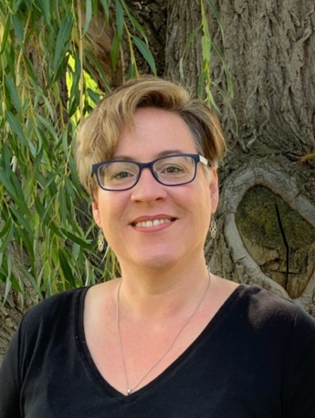

**Jennifer D. Alexander, Ed.D.**

Assistant Professor of Education

Office: Spalding, Room 236

E-Mail: [*jdalexander@lcsc.edu*](mailto:jdalexander@lcsc.edu)

Phone: 208-792-2430

|  |  |  |  |  |  |
| --- | --- | --- | --- | --- | --- |
| **Spring 2023**  Dr. Alexander is available during office times indicated below and  **additional times, by appointment.**  Please contact her by email (jdgardner@lcsc.edu) to schedule an appointment. | | | | | |
|  | **Monday** | **Tuesday** | **Wednesday** | **Thursday** | **Friday** |
| **\* Week 4 of the semester I teach every morning from 8:00 – 11:30 \***  **ED 426 Fine Arts Methods in MTB 103** | | | | | |
| **8:00** | Grade and Prep | Grade and Prep | Interns and Prep | Grading and Prep | Service and Scholarship |
| **9:00** |
| **10:00** |
| **11:00** |
| **12:00** | **Office Hours** | **Office Hours** |
| **1:00** |
| **2:00** | Division Meeting |  |  |
| **3:00** | RE/SE 342  MTB 102 | RE/SE 342  MTB 102 |
| **4:00** |  |

Courses for SPRING 2023:

RE 307 Literacy Leadership (online)

RE 309 Disciplinary Literacy (online)

RE 342 Intermediate Literacy (MTB 102)

ED 426 Fine Arts Methods (MTB 103)