Warrior Wellness Zone Rules
- Room use by reservation only. 30 min – 60 min time slots available.
- No more than two students can use the room at a time.
- Snacks and drinks may be brought into the room, but no food from the SUB or messy, smelly foods. Water is fine, other drinks must have a screw top lid.
- This space is not intended for use as a study room, please do not book multiple time slots in a row for study time. If you need to book a study room, please do so at the library.
- Be respectful of the people around you.
  - Don’t be too loud, keep the volume on any speakers or noisemakers at or below a certain volume (to be determined).
  - Clean up after yourself – don’t leave trash scattered around and try to put things back where you found them.
- Feel free to use (or not use) any of the objects in the room – if essential oils bother your nose, turn off the diffuser; if you’re sensitive to sounds, turn off the noisemaker or speaker. You don’t have to use anything in the room that is causing you to feel overwhelmed.
- Students are responsible for the condition of the room and its contents. Be respectful.
  - If damage or theft of items occurs, students responsible will be subject to fines.
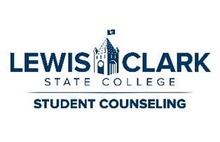
Purpose of the Room

The purpose of the Warrior Wellness Zone is for students to have a place to go where they can decompress and mentally “cool down” outside of counseling. It can provide for students who are in distress (but not in crisis) or in need of a soothing environment a place to go to take their minds off of things for a little while.
The Warrior Wellness Zone is NOT:
- A place for you to study. Please do not reserve multiple blocks at a time/in a row in order to use the room as a study space. By doing so, you are taking the space away from people who may want or need to use the room for its intended purpose: to destress. Please be considerate of your fellow warriors.
  - If you need a quiet place to study, please consider reserving one of the study rooms located in the Library here on campus. You can find the bookings here: https://lcsc.libcal.com/reserve/studyrooms
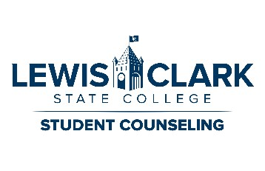
- A place for you to have meals. Bringing in a snack or drink is fine, but please refrain from bringing in any food from the SUB, fast food, food from home, etc. And please remember to clean up after yourself before you go.

