PORTFOLIO ASSESSMENT GUIDE for

ECDPT-104: Introduction to Early Childhood Education

What is a Portfolio:
A Portfolio is a formal means of requesting assessment of your prior work/life experience from which you have developed sufficient college-level learning to earn credit for a specific class.

Purpose of this Guide:
This document is intended for student self-assessment purposes only. Review it carefully to determine if you are ready to write and submit a Portfolio for the course indicated above. Your self-assessment is not a guarantee that you will be awarded credit for the course. Faculty with expertise in the subject matter will evaluate whether your Portfolio provides sufficient evidence that you have demonstrated appropriate college-level mastery of the course content through experiential learning.

General Guidelines:
- All work must be word-processed, except for documentation provided.
- Written portions should demonstrate college-level writing skills, including appropriate citations for any quoted or paraphrased material from other sources.
- Use the provided template, located on page 4 of the guide, to format the portfolio appropriately.
- Your Portfolio will not be returned. Make copies of the contents before you submit. You may include clear copies of documentation and keep the originals.
- Submit your completed Portfolio, along with the approved Course Portfolio Assessment Form, to the Adult Learning Coordinator.

Determination of Portfolio Assessment Outcome:
You will need to do the following to be awarded credit through Portfolio Assessment for this course:
- Provide all required documentation as listed within the template to support the Learning Outcomes.
- Possibly participate in an interview with the Portfolio evaluator.
- When evaluated, students must demonstrate experience or proficiency in >=70% to earn credit in the course.

SCORING:

- Exceeds Expectations (4): Documentation provided demonstrates exceptional knowledge and mastery of learning outcomes. Work is thorough and complete, and free of errors in conceptualization.
- Meets Expectations (3): Documentation provided demonstrates adequate knowledge and mastery of learning outcomes. Work is mostly thorough and complete, and has minimal errors in conceptualization.
- Needs Improvement (2): Documentation provided demonstrates inadequate knowledge and mastery of learning outcomes. Work is incomplete with weak evidence and errors are present in conceptualization.
- Does not Meet Expectations (1): Work provides very little evidence of knowledge or mastery of learning outcomes. Significant errors or inaccuracies are evident, as well as, major errors in conceptualization.

Skill/Outcome | Score
Demonstrates an understanding of the influence of historical and current early childhood education perspectives, theories, program types and philosophies on early childhood care and education today.
Demonstrates an understanding of the role of the early childhood educator, including ethical conduct, and an awareness of professional pathways within the field of early childhood.
Demonstrates an understanding of quality in early childhood programs related to environment, curriculum, and teaching strategies, including play as a vehicle for developing skills.
- Student demonstrates an understand of the differences between state licensing regulations and accreditation standards and how they related to program quality, child outcomes, and teacher standards.
- Student has a beginning understanding of issues facing the field of early childhood care and education related to quality, compensation, and accessibility and can explain why advocacy is so important in this field
Demonstrates an understanding of the developmental needs of children at various ages and stages, birth through age 8 and awareness of developmentally, culturally and linguistically appropriate practices.
- Demonstrates an ability to identify the domains of development and give examples of typical developmental milestones for infants, toddlers, preschoolers, and young school-age children for each domain.
- Demonstrates the ability to describe developmentally, culturally, and linguistically appropriate practices in the early childhood classroom.
Demonstrates a beginning understanding of the nature and purpose of assessing children in early childhood programs and purpose/use of authentic assessment and other authentic forms of assessment.
- Demonstrates an understanding of how standardized assessment differs from authentic assessment.
- Demonstrates an understanding of the importance of knowing how to “observe objectively” and reasons for documenting observations of young children’s skills.
- Demonstrates knowledge of at least three (3) structured observation tools used for authentic assessment in the early childhood classroom.
- Demonstrates familiarity with portfolio assessments and what should be included in a child portfolio.
Demonstrates an understanding of the term child guidance, what appropriate goals are of child guidance are, and effective strategies for managing inappropriate or challenging behaviors.
Demonstrates an understanding of the role and impact of the learning environment, is able to identify ways to arrange space and materials both indoors and outdoors, and can identify how schedules serve to promote learning in early childhood programs.
- Demonstrate the ability to create a floor plan for a high-quality indoor learning environments for a preschool classroom. Able to include use of space, a description of equipment and furnishings, and a list of materials to support routines and learning in each area or zone of the classroom.
- Describe how schedules should be organized in early childhood programs. Compare and contrast different considerations that should be made for each age group: infants, toddlers, and preschool-age children.
Demonstrates an understanding of the nature of play and its contribution to children’s development and learning, as well as strategies for facilitating children’s play.
Demonstrates an understanding of what Developmentally Appropriate Practice is, and demonstrates a beginning ability to facilitate children’s development and skills in the areas of physical development, communication, inquiry, creative expression, reasoning, and interpersonal relationships.
Demonstrates a beginning understanding of the influence of curriculum planning (what you teach), the process of curriculum planning, importance of using program and/or state early learning standards while planning curriculum, and can describe steps in creating an integrated study.
Demonstrates an understanding of inclusion and the benefits of inclusive programs for young children.
Understands the importance of building effective relationships with families, how these relationships support early learning, and strategies for promoting family engagement.
Total Score
Credits Earned

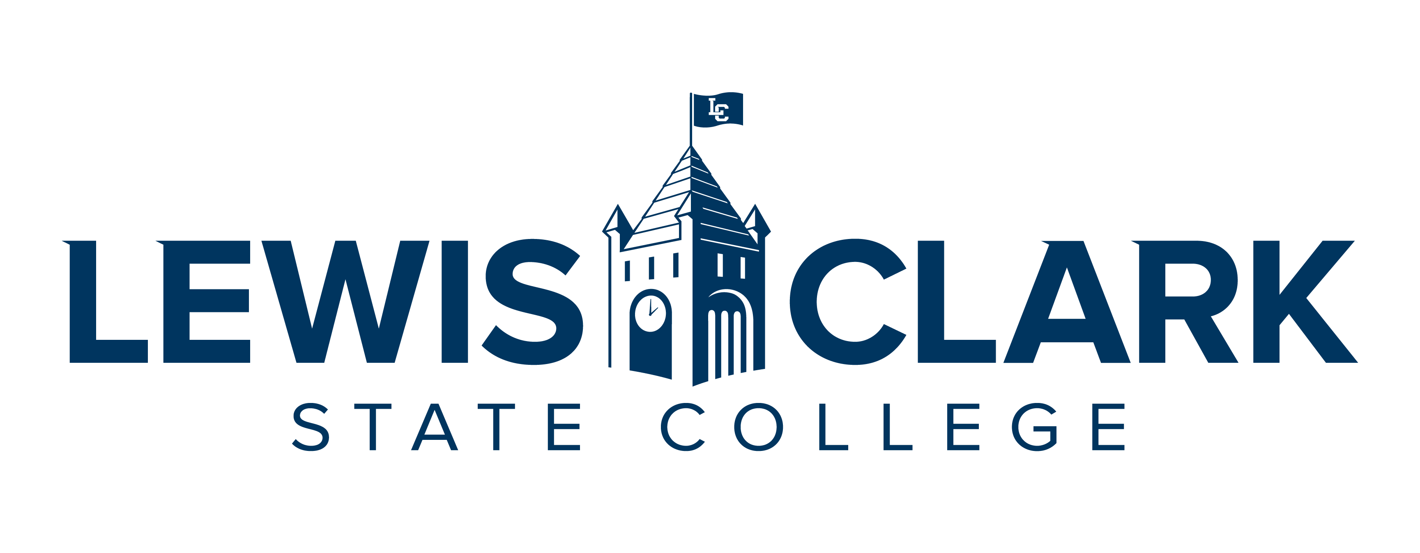

CREDIT FOR PRIOR LEARNING PORTFOLIO

ECDPT-104: Introduction to Early Childhood Education

(DATE)

BY

(YOUR NAME)

Table of Contents
Contents
Statement of Academic Honesty 3
Course Description 4
Learning Outcomes 4
Educational Goals 5
Chronological Resume 5
Learning and Experience Autobiography 6
Acquired Learning and Knowledge Narrative 6
Bibliography 7
Documentation 7

Statement of Academic Honesty

The material contained in this Portfolio honestly and accurately reflects my life, learning, and work experience. I understand that the penalty for falsifying any information or documentation will result in an award of no credit for the Portfolio with no resubmission allowed and may result in other sanctions as described in the Student Code of Conduct.

Print Name LCSC ID Number

_____________________________ ____________________
Signature Date

Course Description
ECDPT-104: Introduction to Early Childhood Education
This course is an introduction to Early Childhood Education and includes an overview of key areas of professional knowledge in the field of early childhood education: developmentally appropriate practices, the role of the teacher, professionalism, observation and assessment, curriculum development, diversity and inclusive practices, partnerships with families, and child growth and development.
Learning Outcomes
- Discuss the cultural, historical, and philosophical influence and the impact on early childhood education today.
- Explore early education programs in the context of family and community relationships, including the need for cultural competence when supporting and collaborating with individuals from diverse backgrounds.
- Understand the theories of child development and how they relate to the implementation of Developmentally Appropriate Practices (DAP).
- Discuss national and state standards for the provision of education to young children and how early childhood education programs meet these standards (Idaho Early Learning Guidelines & NAEYC for children and professionals).
- Review the elements of early childhood education curricula, the theoretical framework for different approaches to what is taught, and the pedagogy of inclusion and universal design.
- Analyze evidence-based research on effective models of early education.
- Examine the early intervention system and the provision of services to support the development of children with diverse abilities and/or those affected by trauma.
- Explore careers in the field of early childhood education, the NAEYC Code of Conduct, and dispositions required for work in the field.
- Reflect on and develop a personal philosophy of early childhood care and education.

Educational Goals

Goals, Motivation, and Time Frame
What are your goals? What are the reasons (professional and personal) you are pursuing your goals? What is a realistic time frame for completing your education?
Prior Learning to Goals
How will the prior learning credit you are requesting fit into their future educational and career goals?

Chronological Resume

Include a chronological resume that will support your request for prior learning. List all jobs held, including volunteer, as they relate to the course that you are trying to receive credit. List duties, skills and expertise used in performing job tasks. When possible, use language similar to that used in the outcomes for the courses.
Examples of Experience:
- Employment, Work Experience
- Workshops, Webinars, Training, Seminars, Professional Development
- Volunteer Activities, Community Service, Committees, Groups
- Military Experience, Occupations, Training
- Licenses, Certificates, Industry Credentials
- Non-credit Courses
- Publications

Learning and Experience Autobiography

The autobiography will serve as an introduction to the evaluator and help them understand the context of your learning for the particular course you are requesting. It is a complete picture of you and your experiences as it relates to the course for which you are creating this portfolio. Relate the relevant experiences to the course in a general explanation (Specifics will be included in the Acquired Learning and Knowledge Narrative). Demonstrate why you have selected this particular course and detail your work and life experiences using your resume as a guide.

This should be two+ pages and summarize the significant learning experiences in your life and describe how your experiences will validate your knowledge of the course content and meet the course outcomes being petitioned for credit.

Acquired Learning and Knowledge Narrative

The narrative is a detailed explanation of how your activities and the resulting competencies were achieved. This is to complement your resume and autobiography. Be sure to link your accomplishments to the course learning outcomes. This will be similar to your autobiography, but will detail your chronological work and life experience history while focusing on the things you have already learned through training and experiences, as it relates to your target course.

Note that a key goal of this section is the learning process itself as you reflect on how your experience relates to key concepts within the learning outcomes in the target course. Clearly focus on the learning objectives (what you know and can do) rather than the experience.
For each experience indicated within the Portfolio, the student must:
- Label each heading, Learning Outcome 1, Learning Outcome 2, etc.
- Include the experience; time spent in activity; description of duties and activities.
- Describe the learning and how it relates to the Learning Outcomes for the course.
- Describe how the learning was acquired.
- Provide documentation as evidence of the experience in relation to the course learning outcomes, and as an indication of the level and appropriateness of content.
- Describe how this experience has influenced and impacted other areas of your life.
This will be 2+ pages in length. Make sure it is clear, concise, and free of errors in sentence structure, grammar, and spelling. It needs to demonstrate college-level writing and critical thinking.

Bibliography

This is not required. The bibliography will include any reading done on the course subject. If you have studied manuals or used other texts to gain your prior learning, include them here. References should be cited in American Psychological Association (APA) style, but your instructor may suggest another format.

Documentation

Each of your experiences and competencies will require verification (evidence). This evidence can take several forms:
- Completion of training programs, workshops, seminars, etc., may be verified through:
  - Certificates
  - Personnel records
- Performance reviews showing competencies
- Job descriptions
- Transcripts
- Samples of work
- A videotape of your speech, theatre work, or music recital
- Licenses
- Honors or award
- Samples of your painting, drawing, photography, or ceramics for a studio art course
- Certificates of attendance
- Letters of verification listing proven competencies from instructors or employers
- Products designed or created by you
- Military records
Each piece of documentation for a workshop or training program must be accompanied by a description page of content for each workshop, training program, or seminar and must show how the evidence relates to the course learning outcomes.

