New Stat​e Employee Enterprise Dashboard Registration
· New employees will receive 2 emails once hired in Luma. The first email lets the employee know that a separate secure email will arrive soon.
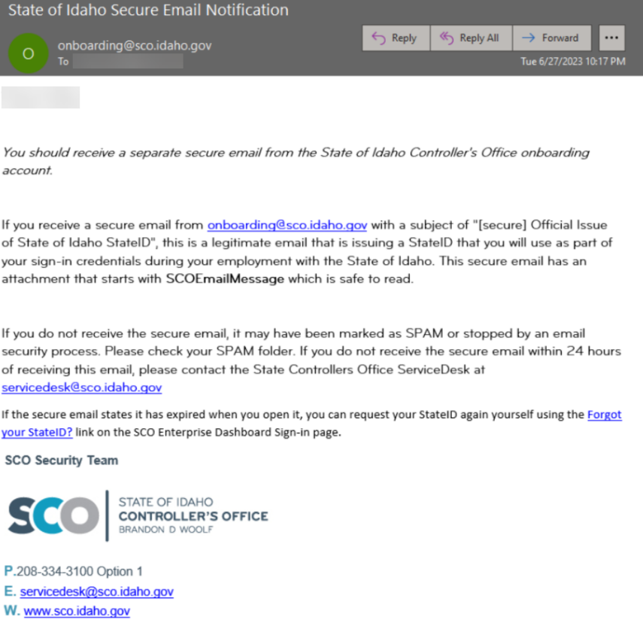
· The second email is the secure email that contains the employee's StateID. To open, select the Read Message button within the secure email. This will open in a new browser.
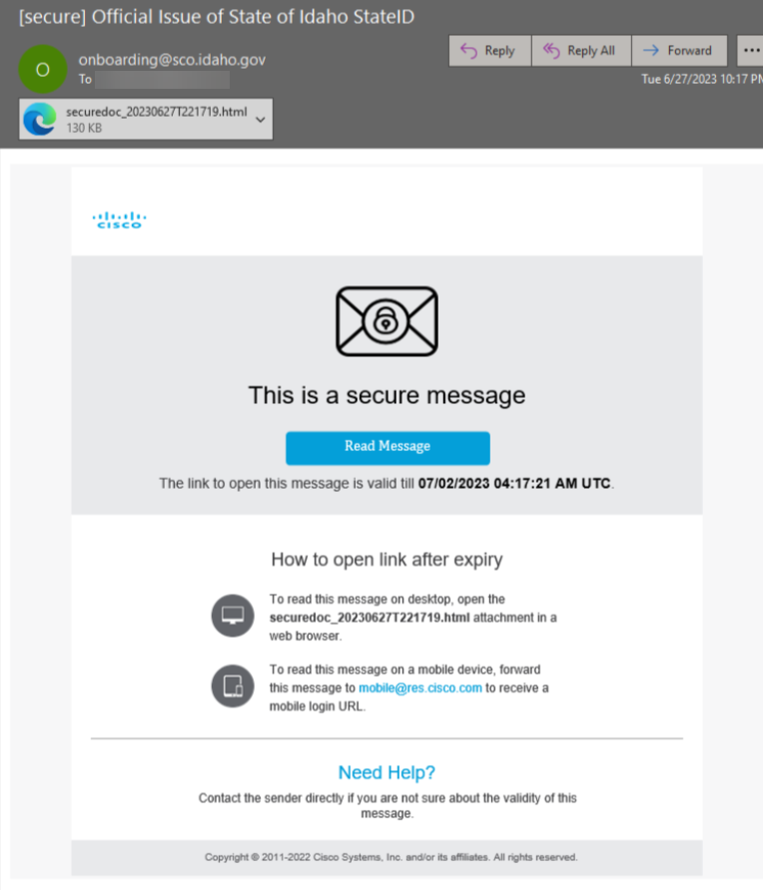
· In the newly opened browser, select the Acknowledge button and the secure email will display. Along with the StateID, this email contains instructions on how to set up an initial password.
NOTE: If the secure email is not received, check your Junk/Spam folder. If the email is not there, follow the Forgot my StateID instructions below.​​
· Luma can be accessed from the Sign-In page, which is accessible from the SIGN IN button on the SCO website.
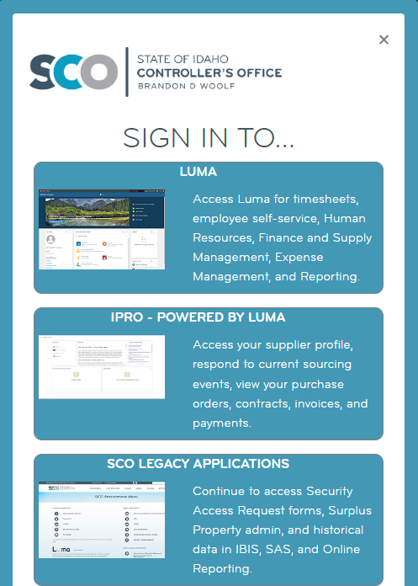 ​
Password Complexity
· Minimum length should be at least Fourteen (14) characters​
· Must contain at least 1 upper case character​
· Must contain at least 1 number
· Must contain at least 1 lower case character
· Must not be a palindrome
· Must not contain any character more than 4 times consecutively
· Must not have 5 consecutive character(s) from username
· Must not contain restricted patterns or be the same as previous 24 passwords
​
Additionally:
​​​
· Will expire every Sixty (60) days and require change during next Sign-in
· Account Lockout occurs after Three (3) invalid sign-in attempts and lasts for 2 hours​

Expired Password
Once 60 days has been reached without a password change, the system will automatically redirect you to change your password when logging on.
1. Enter and verify a password that meets all of the previously-listed requirements, and click Proceed with registration.
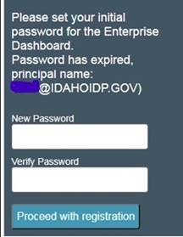
2. Click the link to return to the sign-in page once password has been set successfully.
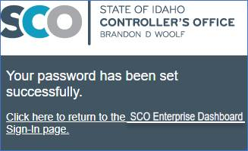

Forgot your Password or Unlock your Account
State employees have the ability to Reset their Password AND Unlock their Luma accounts using email confirmation authentication.
**Please contact the SCO ServiceDesk for direct assistance with this process if needed.
1. Select the Forgot your Password? Link.
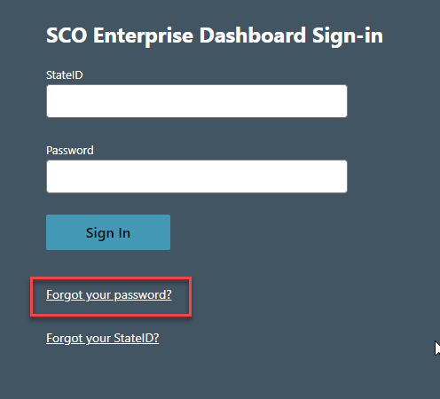
2. A new window/tab opens to the ADSelfService Plus page. Select "Reset Password" or "Unlock Account" depending on what you need.
​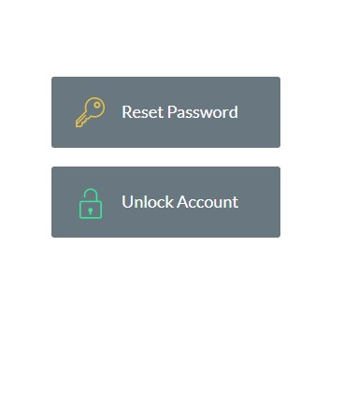
3. Fill out the Forgot your Password? form:
o Enter your State ID number in the Username field (assigned when you registered)
o Make sure the domain of IDAHOIDP is listed.
o Type the CAPTCHA characters shown in the box, and select continue.
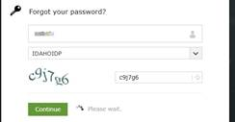
4. Select the Email Verification choice and Continue. (Duo Security presently only shows for some employees)
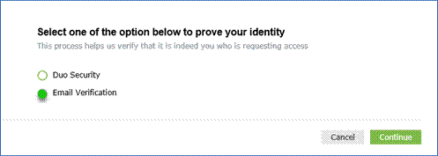
5. Select the Email Address you would like the verification code to be sent to. You may select either your Primary Email address or your Alternate Email addresse from your State Employment record.
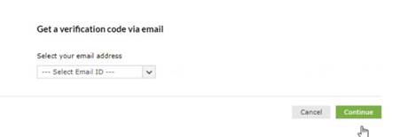
6. An email will arrive to the selected email address from noreply@sco.idaho.gov. Copy the code noted by the red arrow below.
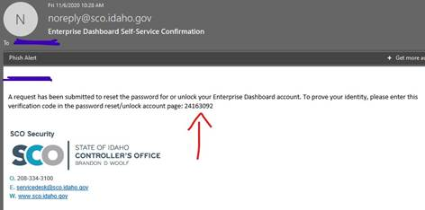
NOTE: If you receive this email WITHOUT having requested any password reset or account unlock, please notify servicedesk@sco.idaho.gov

7. Paste or type the code into the field provided and press Continue.
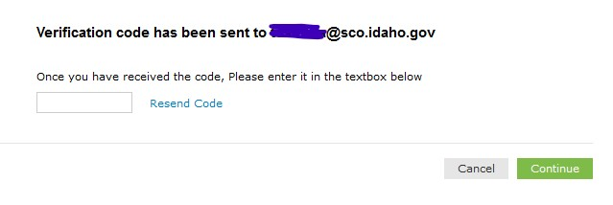
8. If you are Resetting your Password, enter and repeat the new passwords. You are shown visual feedback of your passwords complexity. Once all complexity requirements show green checkmarks, select Reset Password.
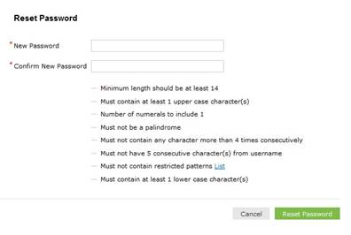
9. If successful, you will receive visual confirmation and email confirmation.
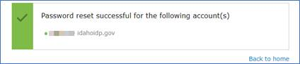

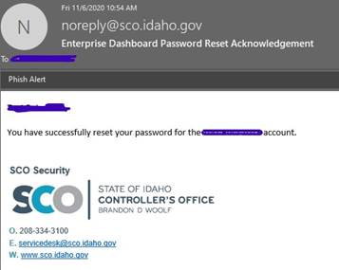
NOTE: If you receive this email WITHOUT having requested any password reset or account unlock, please notify servicedesk@sco.idaho.gov

10. Close browser tab and continue with sign-in. Back to home link will only return you to the Account Self Service page.
Forgot yo​ur StateID ​
1. From the Luma Sign in, select the Forgot your StateID link.
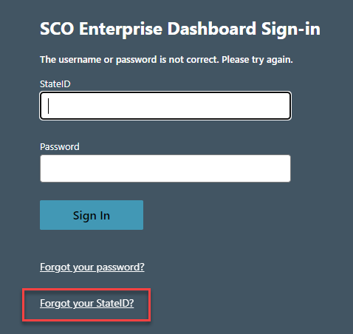
2. Select the red Forgot your StateID link.
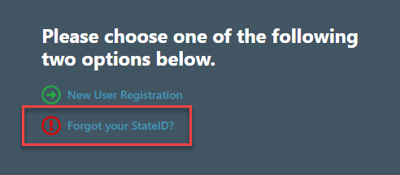
3. Enter either your primary or alternate email address and then select the Validate button.
​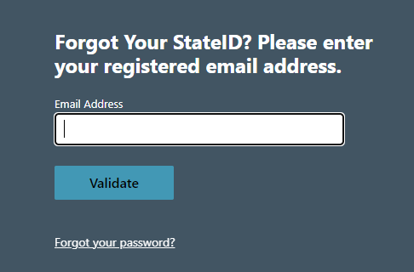
NOTE: If the email does not match, make sure it was entered correctly. If it still does not match, enter your alternate email that is set up. If there is no alternate email set up, it will need set up in GHR.
4. If the email matches, then a confirmation message will display. A secure email will be sent to the employee which will contain the StateID.
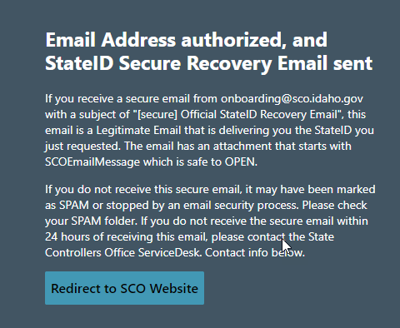
Sign-in Instructions

Enter your StateID and password in the SCO Enterprise Dashboard sign-in page. Select the Sign in button.
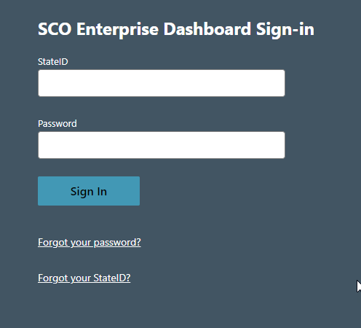
Employees will then be prompted for a second factor of authentication using DUO Multi-Factor Authentication and will be taken to the Luma Statewide Homepage.
Read DUO Authentication Guide​

Statewide Homepage
​​​The Statewide Homepage is where all employees land after signing in to Luma. From here employees can access all they need to including Timesheets, Knowledge, Training and more.
​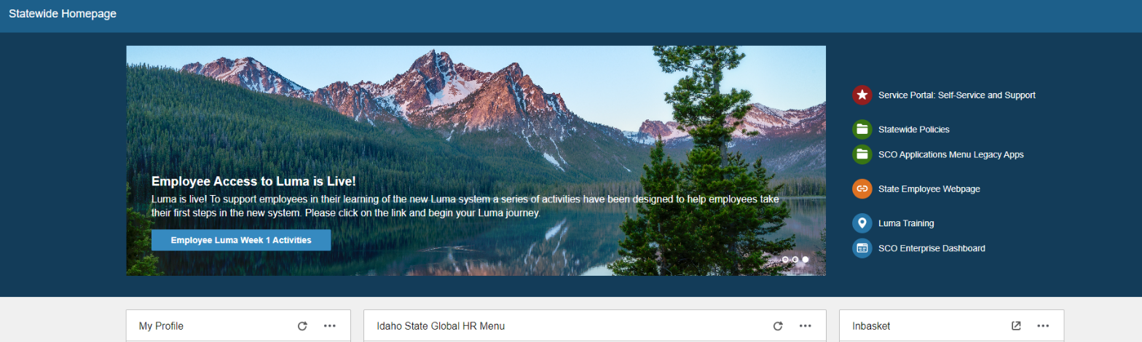
For employees who need to access other applications via the SCO Enterpise Dashboard, select the SCO Enterprise Dashboard link located in the upper right of the Homepage. This will open the SCO Enterprise Dashboard in a new browser tab.
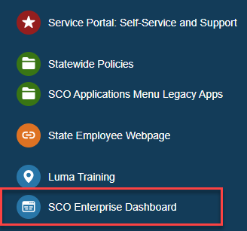
Sign-out Instructions
From the Statewide Homepage, select your name in the upper right hand corner of the screen to open the User menu. Select the Sign out option.
​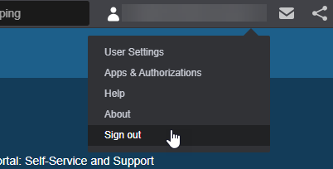​
To completely sign out of Luma, you will need to close your browser after getting to this screen.
​