Good News!
Luma now has Microlearning Interactive Videos available to ALL State employees. These videos do not have audio, and you will need to navigate through them, they do not play automatically. There is also a short quiz at the end of the video to track your completion.
In order to access the interactive microlearning videos, you will need to already have your State ID and DUO Multi-factor Authentication completed. These steps are to be completed on SCO website. www.sco.idaho.gov Select Online Applications.

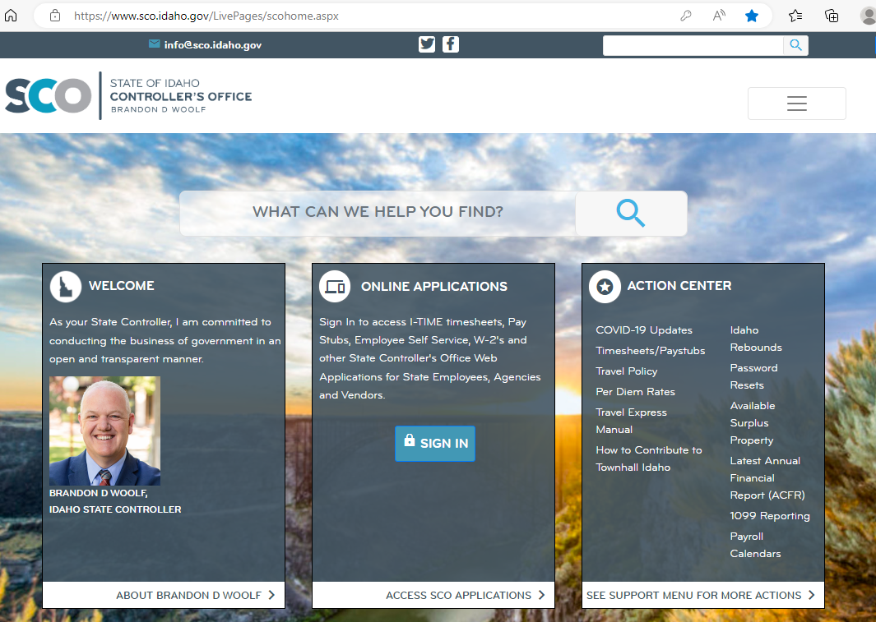

Select Enterprise Dashboard
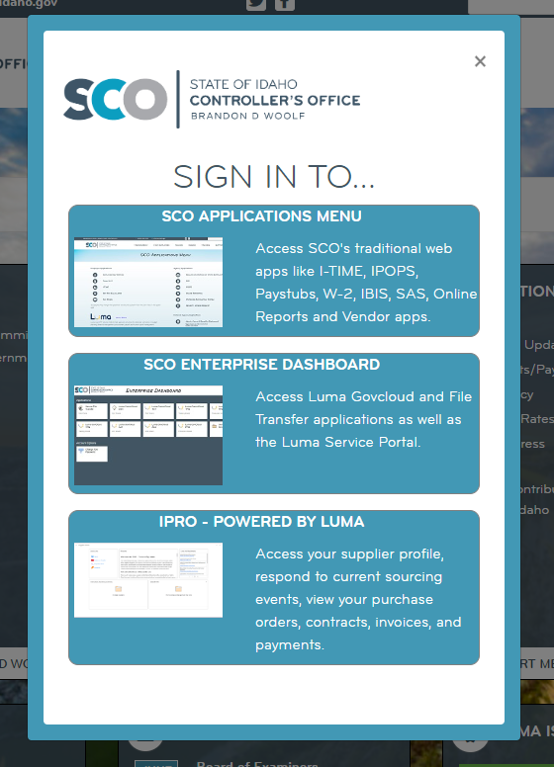

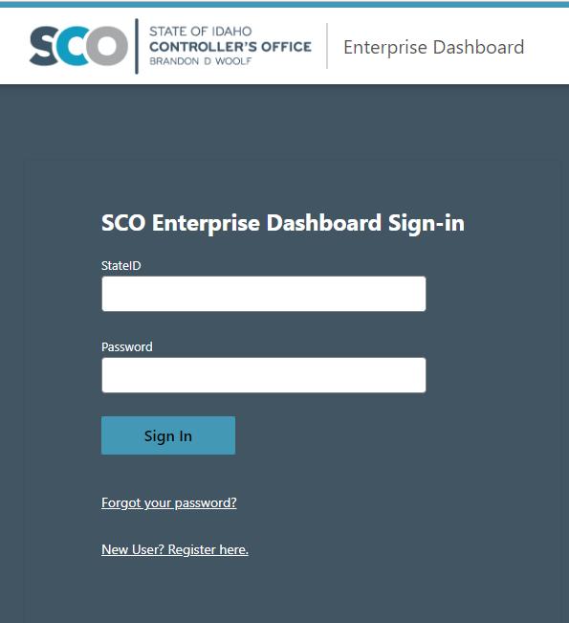

Once you have your State ID and have logged in to the Enterprise Dashboard, you can begin the Interactive Microlearning Videos.

SUPERVISORS & APPROVERS: Please watch the videos for the following three videos so you are familiar with the type of timesheet you will be approving: Basic Timesheet Entry, Timesheet Entry for Cost Accounting, and Advanced Timesheet Entry for Dual Employment.

How to Access Microlearning:
Log in to the SCO Enterprise Dashboard.
Select Luma Training Tab
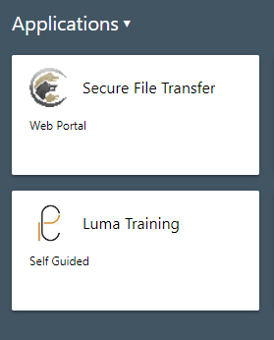

Click the book in the upper right of the screen

Search for Timesheet Entry
Select the training you need:
Professional & Classified Staff will use the Basic Timesheet Entry. Faculty, when completing a timesheet and using leave, will use the Basic Timesheet Entry.
IH & Students will use Timesheet Entry with Cost Accounting. It is important that this timesheet is used so correct coding can be implemented. Note: There will be 5 dropdown selections which will be required. If all 5 are not used, this will cause errors in payroll processing and could cause a delay in the employee getting paid.
Employees with multiple locations (multiple PCNs) will use Advance Timesheet Entry for Dual Employment. It is important that this timesheet is used so correct coding can be implemented. The video shows how to change from one ‘PCN’ to another. Note: There will be 5 dropdown selections which will be required. If all 5 are not used, this will cause errors in payroll processing and could cause a delay in the employee getting paid.
Please note: Executive & Annual Timesheet Entry is not applicable to the majority of employees.

