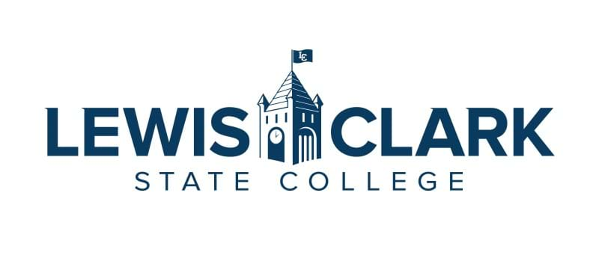
LC-Faculty Leadership Institute
Application Information

Thank you for your interest in joining the next cohort of the LC-Faculty Leadership Institute (LC-FLI)! It will be a reflective, active, and rewarding experience.

What to know:
- This is a 3-semester program, launching SP24 and concluding SP25
- Ideal cohort size is 6-8 faculty members
- Selection is made by the LC-FLI committee (four members), and may involve the previous FLI committee in the case of a tiebreaker
- Applicants may self-apply or be nominated
- Applications are due Wednesday, January 31, 2024

Application process:

In letter or memorandum format, please include and address the following and submit to: LaChelle Rosenbaum, LC-FLI Facilitator: lmrosenbaum@lcsc.edu no later than January 31, 2024.

- Name, years at college, academic division, rank/track
- The LC-FLI is intended to be flexible: to support faculty who are just beginning to consider leadership and those with a much more developed concept of their own potential roles and impact.
  - Why are you interested in the LC-FLI?
  - What is your view of leadership?
  - Where do you think you could have an impact with your leadership at LC now or in the future?

- The LC-FLI is intended to support faculty growth in both formal (e.g. administrative) and informal (e.g. teaching or personal growth) leadership roles. Knowing that your direction may change during this session,
  - Do you currently hold a formal leadership role at LC? If so, please describe your current role.
  - Through participation in the FLI, which type of leadership development are you looking to improve? Formal, informal, or both?

- The LC-FLI program will include: Workshops with topics depending on need, guided project work, literature reading and discussion, cohort meetings, and mentorship.
  - Are there other types of support that would be meaningful to you?
- The LC-FLI program includes a personal/professional/leadership project. In previous cohorts some graduates knew of a project prior to entering the program, while others used the initial spring to develop a project description.
  - Please describe your initial project description if you already have an idea of what you might work on during the cohort.

- The LC-FLI program is intended to run 3 semesters, with the sample plan below.
  - Approximately how much time are you able to commit to participating in the FLI program and completing your project?
  - Do you have time within your upcoming academic schedule to commit to the following tentative plan?
SPRING 2024 | FALL 2024 | SPRING 2025
- Applications due late January  - Cohort kick-off session in March  - Cohort monthly meeting in April: project descriptions due | - Cohort monthly sessions in September, October, and November (project updates, groups discussion & support, leadership topics, and guest speaker(s)) | - Cohort monthly session in Feb.: “Finish Strong” (review of leadership journey & project goal update)  - Cohort monthly session in March  - Project Presentations in late March/early April  - Finale & Celebration in April

- Please discuss your interest in the LC-FLI with your Chair and make sure that your Chair supports your participation in the program.
- Do you have any final concerns, questions, comments or wishes?
LC-FLI committee:
LaChelle Rosenbaum, Social Sciences Division
Jenni Light, Technical & Industrial Division
Kacey Diemert, Teacher Education & Mathematics Division
Suzanne Rousseau, Teacher Education & Mathematics Division

