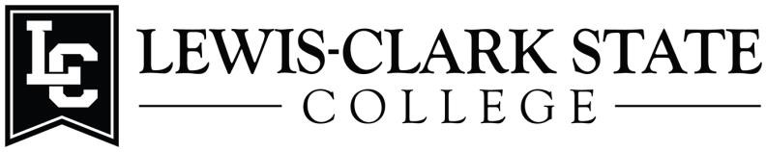

Application for Undergraduate Research Award: HERC-STEM AY 2023-2024

Packets should be uploaded and submitted online after all signatures have been obtained.
SUBMISSION INSTRUCTIONS
Faculty Instructions:
- Students must be enrolled students at Lewis-Clark State College, participating in or willing to participate in Science, Technology, Engineering, or Math (STEM) related research for at least one semester.
- Award recipients must commit to presenting a poster at the Idaho Conference for Undergraduate Research (ICUR) in Boise, Idaho, late July 2024. A copy of the poster must be submitted to the LCSC Office of the Vice President for Academic Affairs via email directly.
- Faculty mentors are responsible for guiding students as they complete the application. Once the student has completed the application, the mentor and student should both sign it. Signing of the application by the mentor and student signifies that both are committed to completion of the project and that the application is accurate and complete.
Student Instructions:
- Complete the application form with the assistance of your faculty mentor. Be sure to answer all questions briefly but completely. Your mentor should assist with prices for supplies, appropriate salary, etc.
- Attach an updated resume, an unofficial copy of your LC Transcript, and records of any transfer credits (TRER).
- Notify your Academic Advisor that you are applying for this award, as s/he may be contacted as a reference.
- Obtain all required signatures.
- A summary report, completed with assistance of your faculty mentor, needs to be submitted to the Office of the Vice President for Academic Affairs office by June 1st 2024. The summary report should contain a brief abstract of the work completed.

LCSC HERC-STEM Undergraduate Research awards are competitive; therefore, incomplete applications will not be considered. If you have questions, contact your Division Chair.
NOTE: Special thanks to the Idaho State Board of Education and the Idaho Higher Education Research Council for the generous allotment of funds to Lewis-Clark State College.

Application for Undergraduate Research Award: HERC-STEM
AY 2023-2024
Student Applicant Information
Name
Student ID#
Phone #
LCMail address
Major
Academic Advisor
Year in School
Cumulative GPA
Project Information
Name of Proposed
Project
Project start & end dates
Faculty Research Mentor
Other Sources of Project
Funding
Estimated Project Expenses
Travel
Supplies
Salary
Total

Explanation of Estimated Project Expenses (provide justification for each item listed as a project expense. When travel monies are requested, specifically address how they will be used (name of conference or research site, dates, cost of attendance, cost of lodging, meals, mileage, etc.) Travel to ICUR is covered and should not be included in travel expenses being requested:

Budget Item |  |  |  |  | Total
Salary | Estimated hours/week: | Number of weeks: |  | Hourly wage:
Travel | Destination: | Total estimated number of miles: |  | Cost/mile:  $0.54
Supplies | Item |  | Cost
 |  |  |  |  | Project Total Cost:

Student Date

Faculty Research Mentor Date

Division Chair Date

