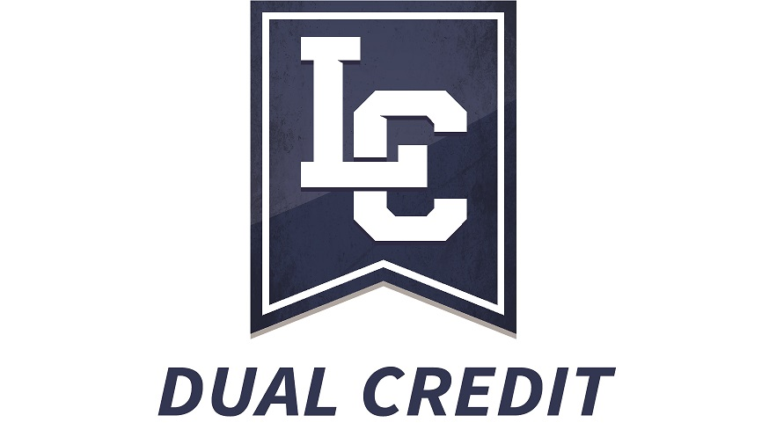

Syllabus Template

Dual Credit course syllabi must include the name of the college.

[Course Information: prefix, number, title, credits]

GENERAL EDUCATION COMPETENCY AREA:

See the General Education Core Requirements list to determine which area is appropriate for this course.

Options (select one):

- Diversity
- Humanistic & Artistic Ways of Knowing
- Mathematical Ways of Knowing
- Oral Communication
- Scientific Ways of Knowing
- Social & Behavioral Ways of Knowing
- Written Communication

[Instructor Information: name, contact information, office hours, etc.]

COURSE DESCRIPTION:

GENERAL EDUCATION LEARNING OUTCOMES: Upon successful completion of this course, you should be able to demonstrate the following competencies:

- Your LCSC Faculty Liaison can provide the specific outcomes (GELOs) for the General Education area this course falls under.

COURSE/SECTION SPECIFIC LEARNING OUTCOMES (if any additional to above):

[Other Instructor-specific syllabus information, including Texts and Materials, Grade Determination, Course Policies, and Assignments follows here. Assignments may include a description of which GELOs each assignment addresses].

