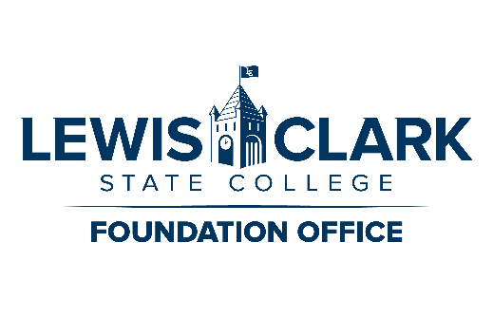
Gift In-Kind Donation Agreement

The Lewis-Clark State College Foundation accepts Gifts In-Kind (property) of various types deemed beneficial to the Lewis-Clark State College (LCSC) and transfers them to the college for use in educational programming, as determined by the college. Therefore, this Gift In-Kind Donation Agreement (“Agreement”), effective as of this ____ day of 20____(“Effective Date”), is made and entered into by and between ___ (“Donor”), whose phone number is: ____ and whose e-mail address is: _____________________________ and whose mailing address is: _______; and the Lewis-Clark State College Foundation for the use and benefit of Lewis-Clark State College and in accordance with LCSC Policies. Donor, Lewis-Clark State College Foundation and Lewis-Clark State College may be referred to collectively as “the Parties” and singularly as “a Party” or “the Party.”

RECITALS
A. Donor wishes to make a charitable gift donation to the Lewis-Clark State College Foundation for the use and benefit of Lewis-Clark State College ___________ __ as set forth in this Agreement.

B. Donor and the Foundation acknowledge that Gifts In-Kind are gifts of property that are voluntarily transferred to Lewis-Clark State College Foundation by Donor without compensation, for use in Lewis-Clark State College programs.

C. Officials of Lewis-Clark State College have deemed gift suitable for acceptance; therefore, the Lewis-Clark State College Foundation agrees to accept such charitable gift, subject to the terms and conditions set forth in this Agreement.

AGREEMENT
NOW, THEREFORE, in consideration of the mutual covenants and conditions contained in this Agreement and for other good and valuable consideration, the receipt and sufficiency of which are hereby acknowledged, the parties agree as set forth below.

1. Gift. Donor hereby pledges to the Foundation this gift for the use and benefit of Lewis-Clark State College__________________.

1.1 Gift Information. Please describe the Gift indicating condition, quantity, brand, type, model,
model number, manufacturer, serial number, etc., if applicable (may include attachment if required for
additional detail): ______________________________________________________________________
____________________________________________________________________________________

1.2 Fair Market Value. $_________________. This valuation determination was made by (please
check one designation): (NOTE: the Foundation can neither assign nor verify a valuation for tax
purposes.) ____ Donor, OR ____ Independent Appraiser (If this option is selected, please attach a copy of the appraisal. Independent appraisals are not required. Refer to Section 4 of this Agreement for more
information).

1.3. Unconditional and Irrevocable. This Gift is given unconditionally, and Donor hereby irrevocably
assigns, transfers, bestows and gives any and all rights, title and interest which Donor shall now have or
may possess in the future in Gift to the Foundation for the use and benefit of Lewis-Clark State College Athletics.

2. Use of the Gift. The Gift shall be used primarily for: Lewis-Clark State College: ____________________. The following restrictions apply to the use of the gift: (list restrictions here)

3. Unforeseeable Circumstances. If it becomes impossible or impractical to use the Gift for the purpose
designated by Section 2 Use of the Gift, or if this Agreement is determined to be in conflict with any
federal, state, or local law, regulation, or ordinance, the Foundation’s Board of Directors, in consultation
with the Donor (if possible) or with Lewis-Clark State College, Lewis-Clark State College will direct the use of this Gift in the best interest of Lewis-Clark State College and in a manner most consistent with the original intent of the Donor.

4. Internal Revenue Service (IRS) Regulations. Depending upon the type of item donated (real estate, art,
equipment, books, etc.), and its estimated fair market value, the Donor may be required to file IRS Form 8283 with their tax return along with an appraisal of the item(s) conducted by an authorized appraiser. The Donor should refer to i8283 and seek advice from their tax consultant on establishing fair market value and be certain how the tax laws regarding In-Kind contributions apply to them. If the Donor intends to file Form 8283 with their tax return, the Lewis-Clark State College Foundation is required to complete Part IV of the Form. Donor and Foundation acknowledge that the valuation of any Gift In-Kind is the responsibility of the donor and/or authorized appraiser. Neither the Foundation nor Lewis-Clark State College are authorized to give a value on any property to a donor for tax purposes. For a Gift In-Kind of any value, Donor is encouraged to seek the advice of his/her tax consultant.

5. Authorizations. I (Donor) hereby (check one): _____ do grant OR _____ do not grant permission for
Lewis-Clark State College Foundation to use my name in donor-related publications, website, or other recognition intended to thank donors and encourage the support of others. If permission to announce is granted, Donor requests to have name appear as: _______________________________________________________________________.

IN WITNESS WHEREOF, the parties have executed this Agreement as of the date set forth above.

______________________________________ ______________________________
Donor Title

______________________________________
Mike Tatko, LCSC Foundation Board President

______________________________________
Cynthia Pemberton, LCSC President

