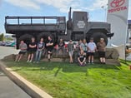

If you have a special talent you would like to share with the SPARC Team or would like to make a donation.

Contact us @ (208) 790-3519

Julie Bieker, Chris M., Lorissa S.

**654112**

Connecting Learning to Life!

500 8th Avenue  
Lewiston, ID 83501

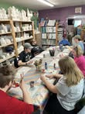 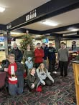 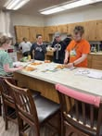

**Our goal at SPARC is to provide a variety of resources and activities in order to create a path of success and independence for students with a wide range of learning abilities.**

SPARC is a program for students with disabilities ages 18–21. It teaches key skills that lead to independence, employment, success, and happiness. SPARC is a partnership between the Lewiston School District and Lewis-Clark State College and is housed on the LCSC campus which allows SPARC students to participate in collegiate experiences and practice real-life skills.

The program staff includes a certified special education teacher and instructional assistant support. Students attend an academic and functional program each day focused on skills related to the students’ post-school goals. Each day students participate in the work experience component of the program. Work sites exist throughout the community as well as on the LCSC campus.

Students routinely use the campus gym, library, and SUB. Students have the opportunity to audit selected courses at the college depending on their skills and interest. SPARC students are also issued an LCSC Warrior activity card that allows access to campus events.

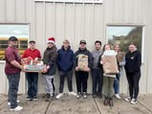

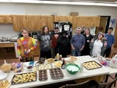

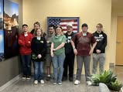

Lewis-Clark State College

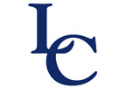

**MISSION STATEMENT**

Students and Professionals

Accessing

Resources in the Community

**Program Description**

**Vocational Training/ Career Development**

Our primary goal is to prepare students for successful and meaningful employment. Teachers and students work together to determine students’ occupational interests and abilities with the aim of increasing vocational skills and preparing students to be employed, contributing members of the community.

ACTIVITIES ACTIVITIES ACTIVITIES ACTIVITIES

**CURRICULUM AREAS**

**SPARC HAS A PROVEN RECORD OF HELPING STUDENTS BECOME MORE INDEPENDENT, WELL–ROUNDED, CONTRIBUTING MEMBERS OF SOCIETY.**

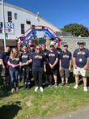  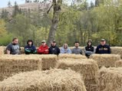 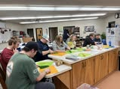 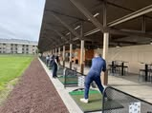

**Social Skills and Personal Management**

Students participate in ongoing development of social skills for maintaining successful relationships by participating in discussions, role-playing, and practice in real life situations.

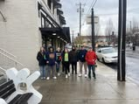 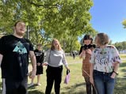 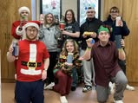 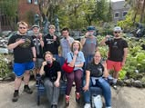 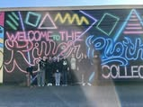

**Recreation and Leisure**

Students participate in activities on campus or in the community. Instruction builds student awareness of what opportunities are available and how they can take part.

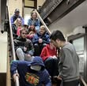 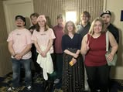 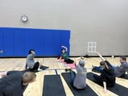 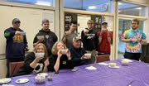

**Eating in a Public Setting**

Students routinely eat in the community or at the Student Union Building Food Court where they learn how to read menus, order food, identify correct money to pay the bill, use appropriate table manners and stay within budget.

**Grocery Shopping and Meal Planning**

Students plan, budget, and shop at area grocery stores and prepare meals using the kitchen facilities available on campus.

**Functional Daily Living**

Students build independent living skills. Activities include money skills, budgeting, scheduling, cooking, banking, telephone skills, functional reading, computer skills, bus training, safety issues and community awareness.

A student’s time in the program is individualized based on preferences, strengths, interests, and needs. Their participation in the program may continue through the semester in which the student turns 21. The curriculum is also adapted to fit individual needs. SPARC curriculum includes vocational training/ career development, social skills, personal management, recreation/leisure, personal independence skills.

SPARC is a creative partnership that gives transitional students the significant support they need to become independent, employed, successful and happy in a college setting where they interact with other students their age. Enrollment to the program is by application and interview in the senior year of high school, allowing the student to participate in commencement and time to plan for the transition to SPARC.

After more than ten years in existence 100 % of students desiring employment either had a paid work position or were in the process of an employment evaluation before the end of the first semester. This year all interested students are in process of obtaining competitive employment.

**Self-Advocacy**

Students learn to advocate for themselves and others with disabilities locally, statewide, and nationally. Students learn to speak for themselves, ask questions, ask for help, resist peer pressure and facilitate their own IEPs.

**Self-Determination**

Students take responsibility for themselves, take an active role in planning their future, make choices and decisions and incorporate what they are learning into their adult lives.