2019-2020 Officers:
Chair: Cindy Patterson
Vice-Chair: Angela Meek
Secretary/Treasurer: Johanna Björk
Digital Comm: Kati Wilson
_____________________________________________________________________________________
PSO Meeting Agenda
November 11, 2019
3pm; TJH 108
- Call to order
  - Cindy called the meeting to order at 3:00pm. 22 PSO Members attended.

- Speaker: Dawn Lesperance. Director; e-Learning Services, LCSC Testing Center, & Disability Services
  - Viewed Disability Services Page
  - Updates in the department:
    - Originally when Dawn was hired at LCSC it was to manage eLearning and Testing. These job duties have expanded to encompass other areas.
- Oversees learning management system for the College – currently Blackboard.
- Blackboard is due to go away in July 2020.
        - An announcement will go out, shortly concerning who is taking over the College’s LMS system.
Testing center – Update/Location
Located in Library – all kinds of test and administered: ACT; CLEP; DDST site, fully funded Dante site, testing for work force training, professional exams, and Praxis testing, and also manage accommodations testing.
Two full time testing staff and one staff that is .77.
Changes (January) – changing name to “Accessibility Services” from “Disability Services.” Starting in January “Accessibility Service” employees are Robin Van Sickle and Autumn Greene. Autumn is the new coordinator. In October Dawn and Autumn attended coaching training in Boise. What can we do to help you to be more successful? Seeing fairly good response.
Disability Services goes beyond just accommodation. 1) Offer more resources, partners/collaborates with more people on campus. Currently working with Student Health, CAMP, TRIO, Resource Center, and other groups on campus. Disability Services is located right next to the Testing Center. This area was resigned during summer 2019 to include a new office space. This increases the comfort level of the area for students and other users.
2) What assistive technology can we provide our students? We want to find ways to help the students be more productive. Read & Write is an example.
Final piece – increasing accessibility across campus for all areas of campus. All documents are screen readable are captioned and ADA compliant. Autumn will work with departments on ADA compliancy on campus.
LCSC is ahead of all campuses surrounding us concerning this accessibility aspect.
Question – will the changes work with new the system? Umbraco and Webaim will show if our resources will be accessible on the new site.
Celeste responded– when are you hoping to make the name change, but probably will happen at physical year.
- Approval of minutes from October 14, 2019. Minutes approved by Kevin Reynolds, seconded by Kati Wilson
- Committee Reports
  - LC Cares – Vikki Swift reported boxes are in the campus buildings for food and toys. Everyone should have gotten the Albertsons bag.
  - Compensation Review Committee – Vikki swift reported CRC will have its first meeting this week, nothing further to report at this time.
  - Functional Area Committee. Kati Wilson – No report. Still in UAR process.
  - PSO Mentors. Vikki Swift did a training. Currently not a huge demand due to the few employees hired.
  - PSO Employee of the Year – Angela Meek and Cindy Patterson lead discussion.
    - Change of employee of the year (EOY) process
    - Email sent. Changing from general voting to a committee process similar to CSO. Moving to an objective (non-biased) process. Make certain that people doing awesome works on campus are being recognized.
    - Rubric discussed by Angela Meek – viewed. Voting in the bylaws
Dawn Lesperance so moved for the purpose of discussion. Kevin Reynolds seconded to discuss
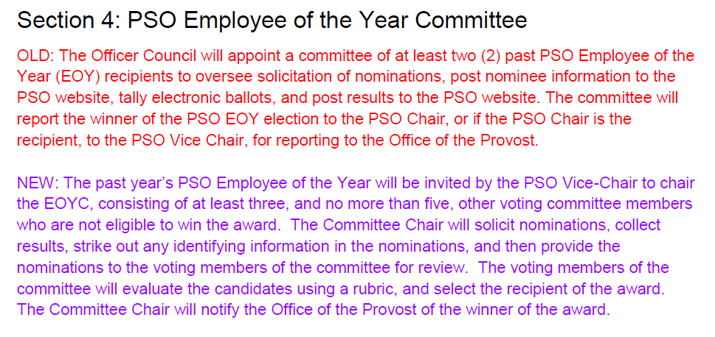
Question concerning committee assignment – the Chair would decide who would sit on the committee. Those on the committee can’t be a recipient.
- Julie Crea– walk us through the nomination process.
- Viewed sample nomination form.
- The only thing the committee members will view is the raw data. No name/any identifying information will be obliterated.
- Viewed rubric
- Dawn Lesperance – this follows how CSO currently does nominations. Cindy Patterson- we reached out CSO for feedback concerning this process.
- Question: What are we voting on? Kati- voting to make sure the processes/procedures for PSO employee of the year is aligned with CSO. We would like to implement this change this year, we need to get this voted on and processed. If the last 5 years of winners were for some reason unavailable, the Chair would be put in charge of finding committee members.
- Question - Should there be verbiage concerning the previous PSO employee not being available? – Angela Meek, verbiage is available.
Discussion Continued – see below
- Celeste McCormick – the second talks about who is eligible to be on the committee – seems to be self-defining. The Chair is not eligible to vote. Add to the proposed change laws to clarify. Clarify “new” employee statement.
- Might be beneficial – Erin Cassetto – to have someone beyond 2 years serving on the committee. Propose that maybe 2 of the previous award winners would be part of the committee.
- Travis Osburn– if that is a concern – can we make a policy that the committee would be selected after nominations are done? Cindy – the selection process can be more in depth and take more than one meeting, time would be a concern if the committee was selected after nominations closed instead of before
- Cindy Patterson– add committee have two of the previous 5 year winners and 3/new years or less. Or wait until after nominations are over. Erin Cassetto –committee makeup must be made before the nominations coming in. January meeting, establish the committee from volunteers, 2 years or less. Celeste McCormick – start with winners and then backfill. Angela Meek– CSO had a stipulation that if you served on the committee you can’t serve for 5 years.
- What does CSO do? – Reaches out to HR, gets a list of employees two years or less. Then they approach individuals.
- Debra Lybyer – I call for question?
- Cindy Patterson – ready for vote?
- Celeste McCormick – I think we should table the vote
- Cindy Patterson – we followed the bylaws and sent out the proposed changes two weeks in advance of the vote and no one replied to the email
- Erin Cassetto – to avoid previous year’s issues, is there a way to make certain PSO members vote. Katie Wilson – yes. Dawn Lesperance– the link can be shared and was.
- Julie Crea – can’t you put a validation list, so you have to use your email? Prepopulate the list. So if the person doesn’t use their email, then the person will not be eligible to vote.
- Winner needs to be submitted to Provost by March 13.
- Cindy Patterson called for a vote: for moving to the new process and approving the changes in the bylaws as approved to the day. Show of hands. It passed.
- Moving forward with changes to bylaws and changes to employee of the year process.

  - Professional Development
  - Vikki Swift reported (viewed PDT Website). Currently utilizing workforce trainings software. If you scroll down the page, the user can view the PDT courses available to LC employees. The user enrolls yourself. Next PDT meeting tomorrow. Old website is gone. From July 1st. Question(s): Angela Meek– is there a link on the LC intranet to the new PDT Sit? Answer: One could be added. Dawn Lesperance – is there a cut off time for event registration like previously? Vikki will check into this.
    - If you attend the PDT at the last minute, let Vikki Swift/HR know.
    - Some of the courses cost. Please check to see if there is a discount on the course if you wish to pursue the class. Contact that department.
  - Professional Staff Hearing Board
    - Cindy Patterson – No report
  - Winter Revels
    - Dawn Lesperance reported– Winter Revels is happening Dec 6 (4-6pm) at Williams’s conference center. Sent an email about baskets. RSVP should be live. Theme: Ski Lodge. More information can be located on the Intranet. Changes/Food: More seating this year, and food will be interactive. Different food stations and hospitality students will preparing the food. If you have old skis, to borrow, will not be destroyed. Put your name on them, contact Dawn, Rodney, Jordan about collecting them.
    - Need Snowflakes -
    - PSO Donations -Call Judy Floch– she has all the forms
- Vice Chair Report – Angela Meek
  - Calendar of Events
    - “The Words That Were Our Names: An LCSC Scrapbook” kickoff event By LCSC Institutional Historian, Steven Branting. November 12, starting at 5:30pm. Center for Arts and History
    - Warrior Wellness Walks. November 13, 12-12:30. December 11, 12-12:30. RSVP at LCSC.EDU/PDT
    - Discover LC: T&I. November 13. 10am-11am
    - Juggler Alex Zerbe. Thursday, Nov 14. 8-9pm, Silverthorne
    - Rock The Final Study Night. Dec 3 & 4, 5pm-8pm. LCSC Library
    - Discover LC: Library. December 4. 2:00-3:30pm
    - Winter Revels. December 6th. 4-6pm. WCC
  - Committee Openings - No report
- Treasurer’s Report –
  - Johanna Bjork reported $1712.69 (11/11/19 @ 2:50pm). October: $87 revenue/ $30 spent. November: $43 Revenue/Nothing spent - yet.

- Digital Communication Report -
  - Kati Wilson reported– Everything has been sent out.

- Chairperson’s Report
  - Presidents Council
    - Cindy – presented. Angela Meek is filling in for Cindy at the next President’s Council meeting.
- New Business
  - Johanna Bjork briefly discussed the recent changes to the Library Advisory Committee. Committee was restructure to meet the guidelines/requirements established by the Northwest Commission on Colleges and Universities (Standard 2.H). Please direct any questions/inquiries concerning the newly restructured Library Advisory Committee to Johanna Bjork.
Committee members:
    - Library Director - Johanna Bjork
    - IR&E Representative
    - Two Faculty members (2 year assignment; staggered terms)
      - Liberal Arts & Professional Studies
    - Student representative junior level standing.
    - E-Learning representative. – Angela Meek
- Drawings
  - Donna Callahan,
  - Kim wolf
  - Travis Osburn

Adjournment - Dawn Lesperance motioned to adjourn/Kati Wilson seconded motion. 4:11pm.

