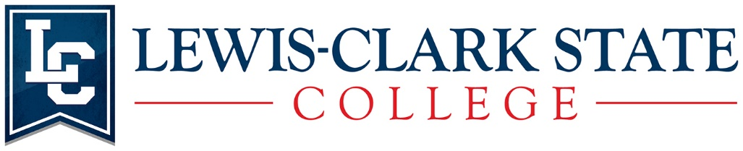
Hybrid Bachelor of Social Work Curriculum

Full-Time Program

At LC State advisors are dedicated to working individually with each student and their curriculum plan. Therefore some courses may be rearranged while others need to stay in their predesigned sequence.
*SW340 is offered each summer
**Non-Social Work Program electives (SS300/400) may already be fulfilled by previous courses taken. Please request your advisor to review your LC State transcript and transfer equivalencies.
***Hybrid: Commitment to travel to Lewiston and or Coeur d’Alene Idaho for Saturday or Sunday intensives. Location is determined by the instructor.

