Student Planning for Faculty: Requisite Waivers
Requisite Waiver is for courses that have pre or co requisites.

Requisite Waiver
Go to your roster by clicking the faculty tab.
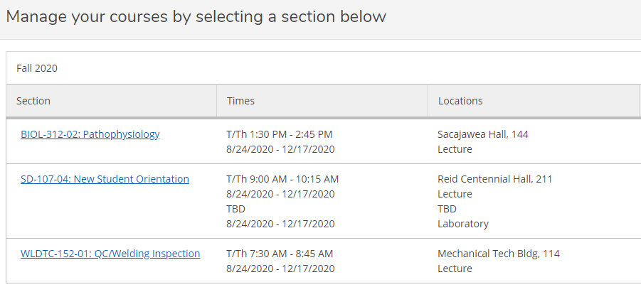
Select the class and click on the Permissions Tab, then click Requisite Waiver.

Search the student you would like to waive the requisites for. You can enter the student ID number or search by name. Once the student has been selected the Add Student Waiver box appears. Select a Waiver Reason, input comments and save.
NOTE: This process will approve ALL requisites.
