Student Planning for Faculty: Faculty Consent
Faculty Consent: when a course requires the instructor permission to take the class.

Faculty Consent
Go to your roster by clicking the faculty tab.
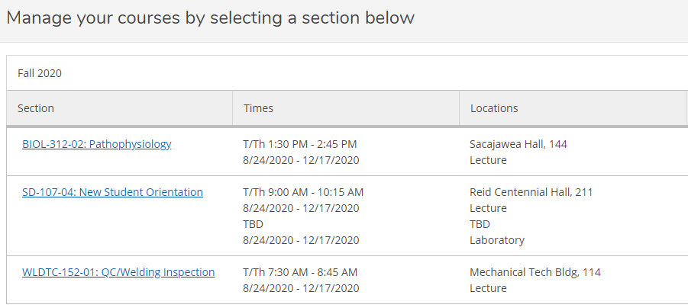
Select the class and click on the Permissions Tab, then click Faculty Consent

Search the student you would like to grant permission. You can enter the student ID number or search by name. Once the student has been selected the Add Faculty Consent box appears. Select a Status, Reason, input comments and save.
