Instructor use of Add Authorization:

Start by logging into WarriorWeb Faculty MenuStudent Planning to get to Self-Service.

Open the Briefcase Icon and expand Faculty to get to the Faculty Overview.
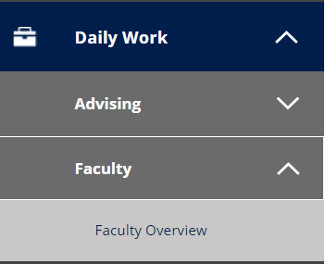

Select a course by clicking the hyperlink.

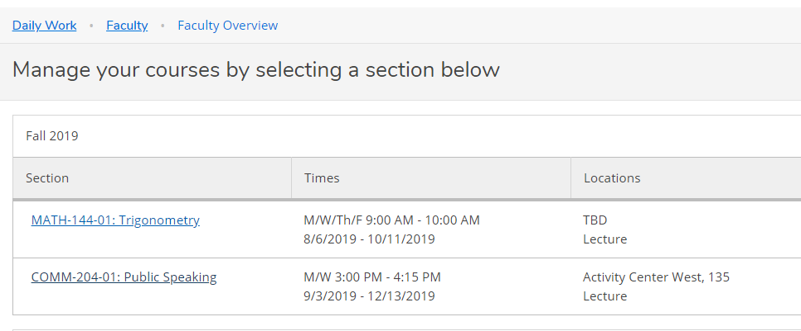

Click the Permissions Tab and the Add Authorization feature.

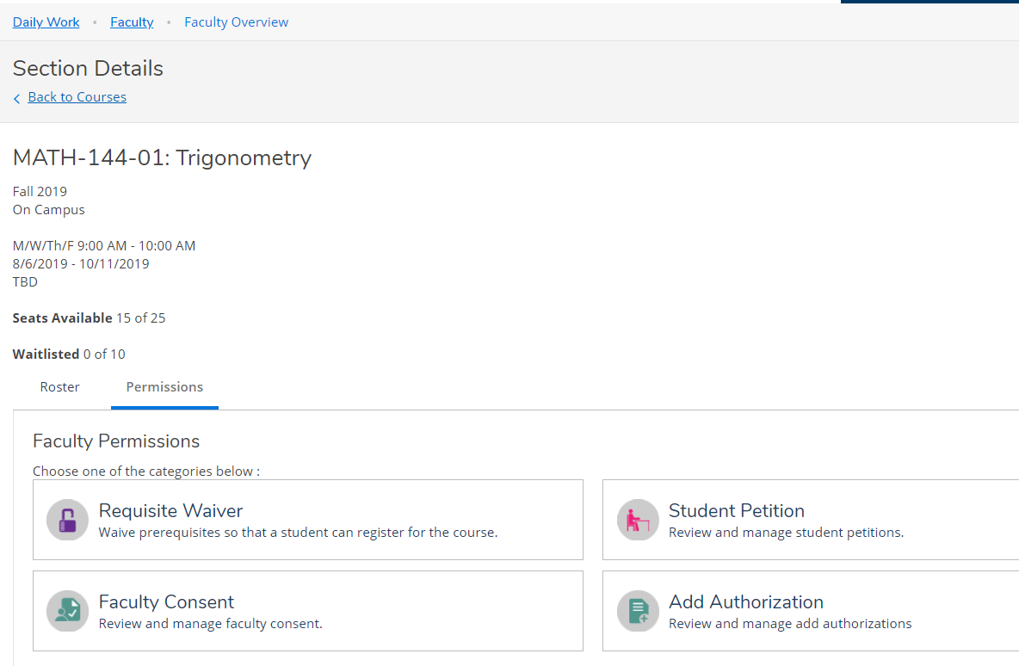

Use the search box to find the student. Look up by name or full seven digit ID. 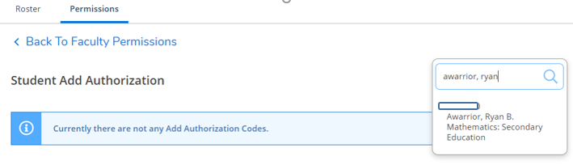

When found, click the student’s name to add and ‘OK’ confirm your choice.
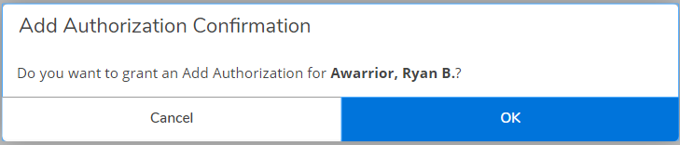

Confirmation is displayed in upper right corner by login information.

Student is now on the list, indicating add permission granted.

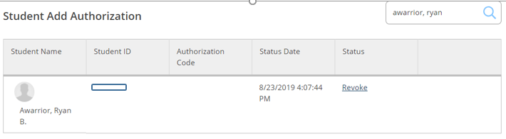

If you change your mind and don’t want to allow the student in the class, click the Revoke link.

When student is added to the class, they will appear on the Roster, and as Registered on the Add Authorization tab.
