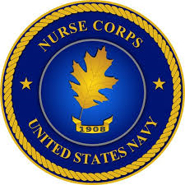

Nurse Candidate Program (NCP)

The Navy’s Nurse Candidate Program provides financial incentives to nursing students obtaining their BSN degree and are graduating between October 1st 2022 and September 30th 2024.

What you receive is:

- $10,000 Accession Bonus

- $1,000 monthly Continuation Bonus for up to 24 months

There are no Navy obligations while in the NCP and you will have a guaranteed Nursing position in the Navy’s Nurse Corps upon graduation and passing of the NCLEX.

Applications are due July to August 2021

For more information contact NCC John Liston at (406)533-5447.

