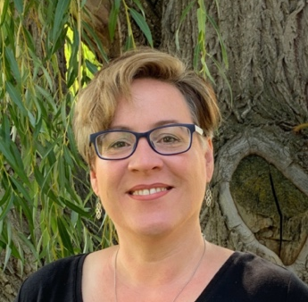
Jennifer D. Gardner, Ed.D.
Assistant Professor of Education

Office: Spalding, Room 236
E-Mail: jdgardner@lcsc.edu
Phone: 208-792-2430

Schedule for Dr. Gardner, Spring 2022
Dr. Gardner is available during office times indicated below and
additional times, by appointment.
Please contact her by email (jdgardner@lcsc.edu) to schedule an appointment.

 | Monday | Tuesday | Wednesday | Thursday | Friday
* Week 4 and Week 7 of the semester I teach every morning from 8:30 – 11:30 *
ED 426 Fine Arts Methods / ELA Methods
8:00 | Grading and preparation | Grading and preparation | Working with Interns; Preparation | Preparation | Scholarship, Service, and Preparation
9:00
10:00
11:00
12:00 | Division meeting
1:00 |  | Office Hours |  | Office Hours
2:00
3:00 |  | RE 342  3:00 – 4:40 |  | RE 342  3:00 – 4:40
4:00

Courses for Spring 2021:

RE 309 Disciplinary Literacy (online)
RE 342 Intermediate Literacy (MTB 102)
ED 426 Fine Arts Methods (MTB 102)
ED 426 ELA Methods (MTB 102)

