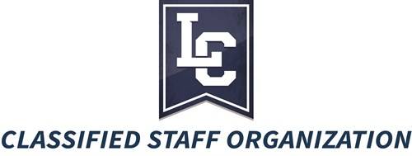
Minutes

December 16, 2021

3:00 pm
Zoom

Meeting Facilitator: Diana Higgins, Chair
Officers: Jeff Zimmerman, Leilani Farrell, Julie Kvern, Jeanette Seward
- Call to Order by Diana at 3:02 p.m.
- Welcome and Introductions
  - New CSO Employees - Jeff Zimmerman
    - Kelsie Page, Financial Technician, Controller’s Office
- Reports
  - Approval of Minutes from December 2021 Meeting – Diana Higgins
Jeff moved to approve, Karen seconded
  - Treasurer’s Report - Leilani Farrell
    - Giving back to LC State, employee payroll donations
(We forgot to approve)
- Old Business
  - Amanda Greco and Ila Duff volunteered for FAC committees; Diana will email to solicit one more person.
- New Business
  - Recognition and Retirements - Jeff Zimmerman
    - Mark Brazington, 5 years
    - Jeff Zimmerman, 10 years
    - Summer Kibbe, 10 years
    - Bryon Olsen, 15 years
    - Jody Wassmuth, 15 years
    - Amy Bond, 15 years
    - Shaun Griffin, 15 years
    - Barb Syska, 20 years
    - Lawrence Norris, 20 years
  - Donation Form – Diana drafted a donation form, modelled on the one PSO uses, to facilitate requests for donations. It will be posted on the CSO website soon.
  - Committee Reports - Diana Higgins
- Winter Revels - Leilani
- LC Cares - Leilani
- President’s Council Report - Diana Higgins
- Next Meeting Date: February 17, 2022 3 p.m. (most likely Zoom)
- Drawing for Door Prizes
  - Congratulations to Ila Duff and Barb Syska, who will each receive $10 in WarriorBucks.
- Adjournment
  - Meeting adjourned at 3:25 p.m.

