**Pay stubs are accessible after you log in to Luma, and from the Statewide Homepage.**

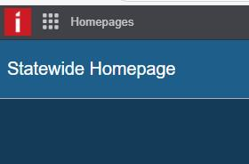

 They are located in the Employee Resources box on the lower half of the page.

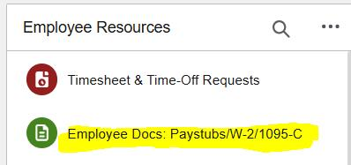

Please let us know if you have any questions, and especially if it concerns your pay stub.

Thank you,

Jane, ext. 2204 or Debie, ext. 2079