All about CourseLeaf CIM:
CIM is used for editing and proposing new courses and programs. Edits could include title or description changes, adding or removing multiple titles, or changing the format of a course. CIM should not be used for updating a term-specific information. Both course and program CIM can be accessed via the Curriculum Committee’s respective webpages.

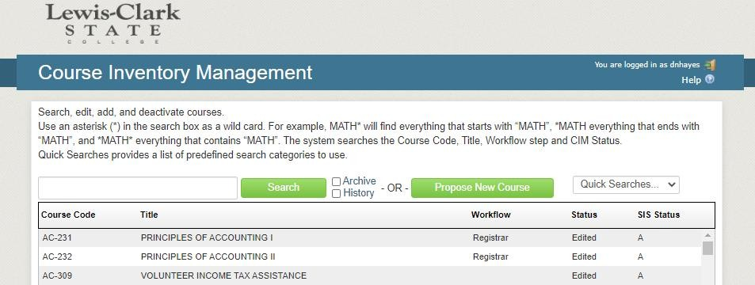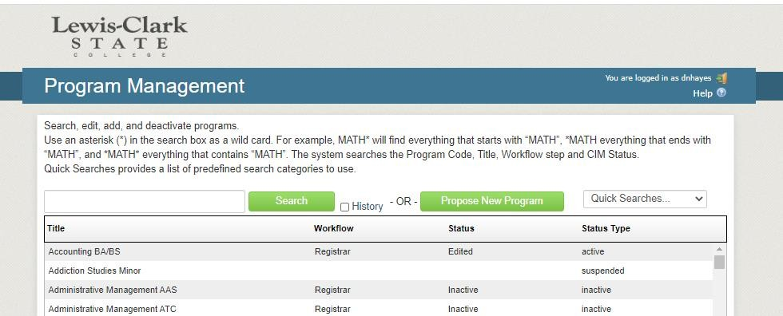
In CIM you can:
- Search for and edit an existing course
- Search by subject code only (e.g. BUS)
- Search by subject code and course number (e.g. BUS-101)
- Search by title
- Propose a new course
- Sort results by Course Code, Title, Workflow, or Status (click the word to sort)

Curriculum Committee Process:
- All course proposals and edits require an approval process through workflow. Once submitted to workflow, a course can only be edited by the members of a given workflow group. Anyone on campus can propose a new course, not just the Division’s designated committee member.

- Before each meeting, the Registrar’s Office will pull all of the courses and programs that have reached Curriculum Chair 1 or Curriculum Chair 2. A list of these courses will be sent to you by the Curriculum Committee Chair. You will need to look over each course and program to determine if there are any discrepancies or misinformation that needs to be edited (Missing syllabi, justification, pre-reqs, etc.). Each proposal will be voted on during the meeting.

- Once you log in to CourseLeaf, you will need to click the “Workflow” column header to group all of the 1st and 2nd reads together. These will be the same items that are on your agenda you will receive before each meeting.

- Again, you will no longer be able to make edits to these proposals (even if you initiated them). It will be up to those in the workflow. If you need to request changes, please contact your Chair or the Registrar’s Office.

- When workflow is started, each step appears on the right of the CIM record.
Green=approved; Yellow=current stage; Gray=pending.
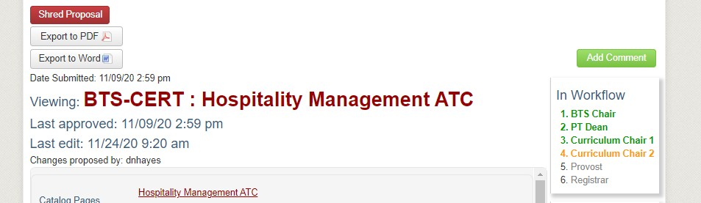
- If you click on any step in the workflow, you will be able to e-mail the person responsible for approving that step.

- Once a course reaches the Colleague stage, Divisions will be able to add the course to their offering schedule for the next school year. Courses are not automatically offered; it is the responsibility of a department to offer the course. Any new programs will be added to the upcoming catalog and to the Registrar’s Office’s PIFs.

How to create a new course proposal:
- Anyone on campus can propose a new course, not just the Division’s designated committee member. All course proposals and edits require an approval process through workflow. Once submitted to workflow, a course can only be edited by the members of a given workflow group.

- Enter CIM (your username and password are identical to your LCSC credentials) and click Propose New Course. A course proposal form will appear in a new window. All fields surrounded by a red box are required, but please complete as much of the form as possible. Click the blue question mark icons for helpful information about each field.
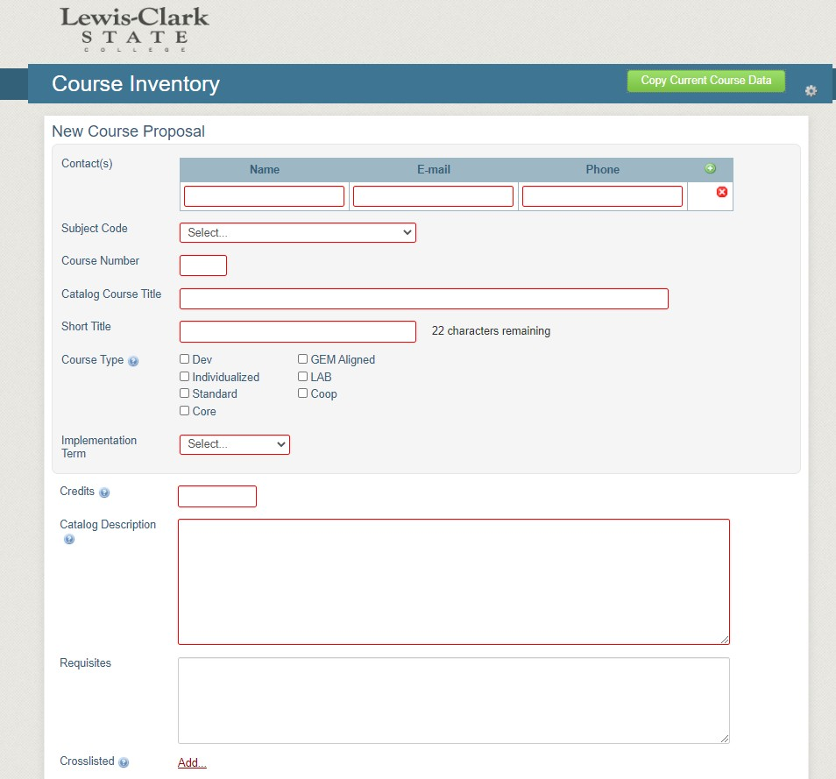

- The number of credits should always end with 2 decimal places (e.g 3.00)

- Your catalog description must match that of the attached syllabus. It must also contain the Requisites that you will list on the next line.

- When you get to the end of the form, you may click Save Changes and continue working on the proposal another time. Once the proposal is complete, click Save & Submit to start workflow.

- You may also copy data from a current course by selecting the green button on the upper right-hand side of the New course proposal. This will have you select a department and course. You will then need to edit the existing data for your new course proposal.
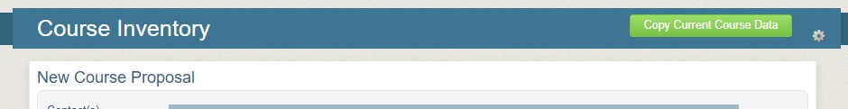

Field Name | Notes
Contact Name, Email and Phone | Contact information to which all inquiries should be directed.
Subject Code | Subject code of the course
Course Number | Select the course number you are proposing. An error will occur if the number is already being used. Be mindful of the level of the course.
Catalog Title | Enter the title of the course affected by the proposal or, if a new course is being proposed, enter the name you wish the new course to be called.
Short Title | Enter the short title of the course up to 22 characters maximum by which the course will be listed on schedules and transcripts.
Course Type | Select Dev, GEM Aligned, Individual or LAB
Implementation Term | Select the term in which the course will be in the catalog. All proposals are effective for the Fall semester.
Credits | Enter the number of credits for the course.
Catalog Description | Enter a concise description that affects a course as it appears in the catalog. Enter a catalog description that meets the following guidelines: Narrative component of 80 words or less, Pass/fail grading, Pre-requisite requirements and Co-requisite requirements.
Requisites | List any proposed changes to existing or new pre-requisite courses.
Crosslisted | List any courses offered under a different subject. (The courses must be identical.)
Session Cycle | Select the term that this course will be offered.
Yearly Cycle | Select the yearly cycle this course will be offered.
Instructor Consent Required | Select Yes or No if instructor approval is required for students to register for this course.
Registration Restrictions | If any, select restrictions to registration.
Pass/Fail Grading | Select whichever option matches the proposed course as it exists, or, if for a new course, as you wish it to exist if the proposal is accepted. View help bubble for additional help.
Allow Audit | Can this class be audited, yes or no.
Course Capacity | Enter the number of students to be allowed to enroll in the course.
Gen Ed Course | If this course is GEM Aligned, see course type.
Create Course Waitlist | Will this course have a waitlist, yes or no.
Resource Impact on Division and College | Detail any resources that might be affected (e.g. faculty workloads, fiscal responsibilities, etc.) and any outside divisions that might be affected (e.g. service courses, pre-requisites, cross-listed courses, etc.). Proposals that the committee identifies as affecting additional divisions, outside that of the author’s, where no indication has been made in this field will be returned to the author.
Justification or Rationale for this Proposal | Provide rationalization for the necessity or importance of this curricular change. Remember that each proposal will be reviewed by many different parties, so clearly state why this proposal is being submitted.
Additional Information | Insert any additional information to support your proposal.
Supporting Documents | Attach any documentation to support your proposal. All courses must attach a syllabus.

How to edit a course proposal:
- Access CIM (your username and password are identical to your LCSC credentials) and find the course you are looking to edit. This can be done either by “Quick Searches” on the right or by enter the course Prefix or the entire course title (including the hyphen) into the search bar.
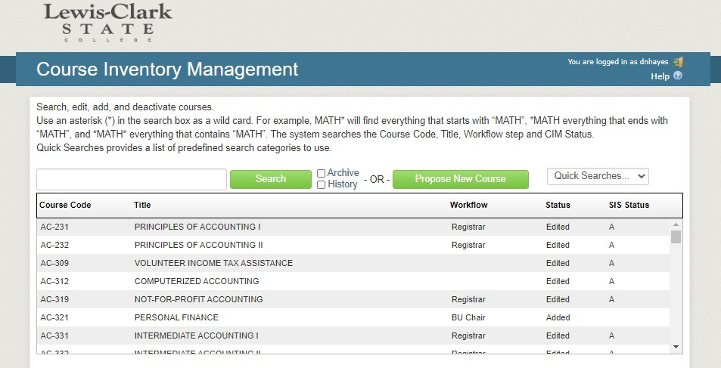

- Select “Edit Course” on the right-hand side.
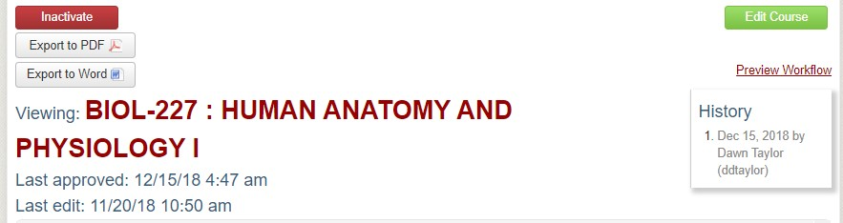
- All fields are then available to edit. Make sure to change your implementation term to the appropriate Fall term.

- You will need to provide an updated syllabus that has the correct course description and requisites.

- If you want to continue to work on your changes at a later date, select “Save Changes” at the bottom of the edit form. If you are finished making changes and want to submit your proposal for the Curriculum Committee for implementation, select “Start Workflow”.

How to create a new program proposal:
- Log in to the Program Management system (your username and password are identical to your LCSC credentials) and select Propose New Program on the right.
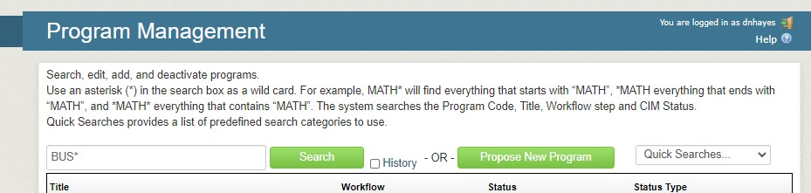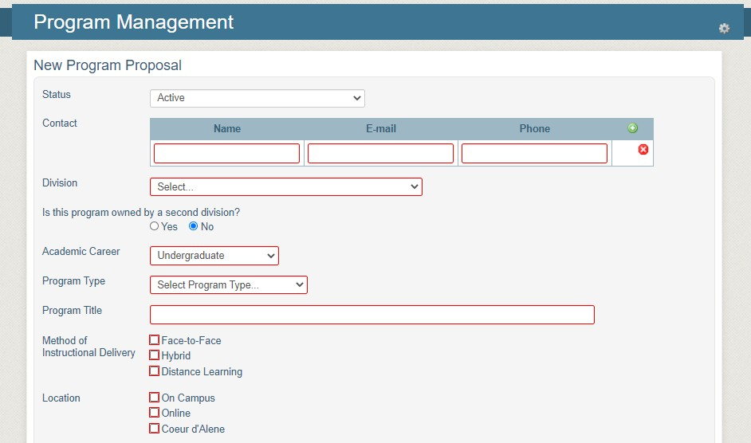
- All required fields are outlined in red.

- All new programs MUST be on the institution’s 3-year plan (housed with the VP of Academic Affairs.)

- The “Program Requirements/Plan” box will be left blank. That is for the Registrar’s Office only.

- The Degree Audit template will need to be filled out completely, or the program will not be built.

- All CTE programs require Attachment Bs.

- If you want to continue to work on your changes at a later date, select “Save Changes” at the bottom of the form. If you are finished making changes and want to submit your proposal for the Curriculum Committee for implementation, select “Start Workflow”.

How to edit a program:
- Log in to the Program Management system (your username and password are identical to your LCSC credentials) and find the program you are looking to edit. This can be done either by “Quick Searches” on the right or by enter a portion of the program title follow by an asterisk (*). It will not give any search results without the asterisk.

- Select “Edit Program” on the right-hand side.

- You will not touch any of the courses that show in the “Program Requirements/Plan”. This is for the Registrar’s Office to edit and comes from the catalog.
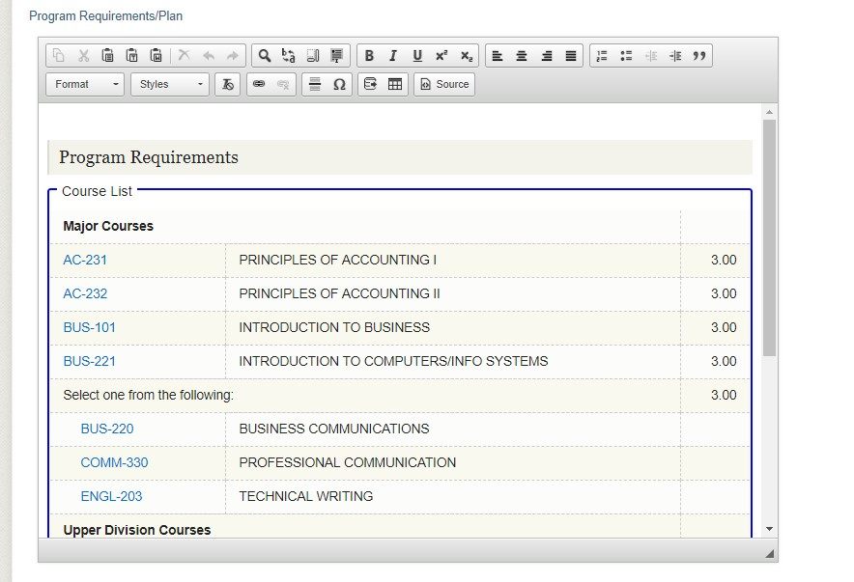
- You will need to enter all changes into the “Briefly describe the nature of the request” box.

- The Degree Audit Coding Template is also required. This is what the Registrar’s Office will use to make your program changes. Make sure you use the appropriate colors for each change, which are found in the key. You may also choose to leave notes or comments if you feel like they are needed.

- All CTE programs require Attachment Bs.

- If you want to continue to work on your changes at a later date, select “Save Changes” at the bottom of the edit form. If you are finished making changes and want to submit your proposal for the Curriculum Committee for implementation, select “Start Workflow”.

