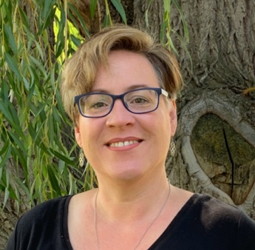
Jennifer D. Alexander, Ed.D.
Assistant Professor of Education
Office: Spalding, Room 236
E-Mail: jdalexander@lcsc.edu
Phone: 208-792-2430

Spring 2026
Dr. Alexander is available during office times indicated below and
additional times, by appointment.
Please contact her by email (jdalexander@lcsc.edu) to schedule an appointment.

 | Monday | Tuesday | Wednesday | Thursday | Friday
* Week 5 of the semester I teach every morning from 8:00 – 11:30 *
ED 426 Fine Arts Methods in MTB 103
8:00 | Grade and Prep | Grade and Prep | Grade and Prep | Grade and Prep  Service and Scholarship | Service and Scholarship
9:00
10:00 | Office Hours | Grade and Prep | Office Hours | Grade and Prep  Service and Scholarship | Service and Scholarship
11:00
12:00 | Meetings | Grade and Prep | Grade and Prep | Grade and Prep  Service and Scholarship | Service and Scholarship
1:00 | Grade and Prep
2:00
3:00 | RE/SE 342  MTB 102 | Grade and Prep | RE/SE 342  MTB 102 | Grade and Prep  Service and Scholarship | Service and Scholarship
4:00

Courses for SPRING 2026

ED 250 Praxis Preparation (online)
RE 307 Literacy Leadership (online)
RE 309 Disciplinary Literacy (online)
RE 342 Intermediate Literacy (MTB 102)
ED 426 Fine Arts Methods (MTB 103)

